Conflicting chip firing games on graphs and on trees
Tra An Pham¹, Thi Ha Duong Phan^{1,2,*}, Thi Thu Huong Tran¹
¹Institute of Mathematics, 18 Hoang Quoc Viet, Cau Giay, Hanoi, Vietnam
²LIAFA Université Denis Diderot, Paris 7 -Case 7014-2,
Place Jussieu-75256, Paris Cedex 05-France
Received 31 October 2007
Abstract. Chip Firing Games on (directed) graph are widely used in theoretical computer science and many other sciences. In this model, chips are ﬁred from one vertex to all of its neighbors at the same time. The purpose of our paper is to study an extended version of this model, the Conﬂicting Chip Firing Game, by considering that chips can be ﬁred from one vertex to one of its neighbors at each time. Our main results are obtained when the support graph of this game is a rooted tree. In this case, we give the characterization of its reachable conﬁgurations and of its ﬁxed points. Moreover we show the local lattice structure of its conﬁguration space.
Keywords: Chip Firing Game, conﬂicting game, convergence, discrete dynamical system, evolution rule, ﬁxed point, tree.

1. Introduction
A Chip Firing Game (CFG) [1,2] is deﬁned on a directed (multi) graph as follows. A conﬁguration of the game is a distribution of chips on the vertices of the graph, and the evolution rule (ﬁring a vertex) is deﬁned by: a conﬁguration can be transformed into another one by transferringa chipfrom one vertex along each of its outgoing edges, if it contains at least as many chips as its outgoing degree. The set of all conﬁgurations reachable from the initial one is called conﬁguration space, and a ﬁxed point is a conﬁguration from which the evolution rule can not be applied. Convergence conditions (involving the number of chips or the structure of the graph) are given in [1-3] as well as diﬀerent proofs of the fact that the conﬁguration space of any convergent CFG is a lattice. See Figure 1 for an example.
CFGs are widely used in theoretical computer science, in physics and in economics. For example, CFGs model distributed behaviors (such as dynamical distribution of jobs over a network [4,5]), combinatorial objects (such as integer partitions [6-9], dollar game [10,11] and other [12]). In physics, it is mainly studied as a paradigm for the so called Self Organized Criticality, an important area of research [13-15]. It is also proved in [16] that inﬁnite CFGs are Turing complete, which shows the potential complexity of their behaviors.

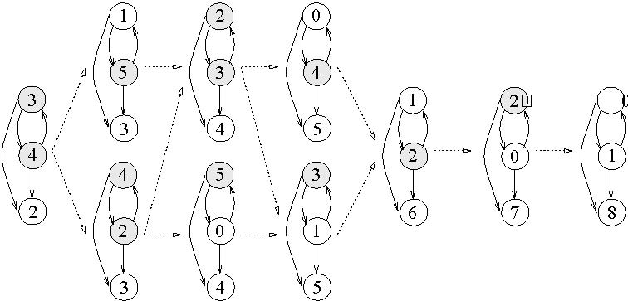
Fig. 1. The conﬁguration space of a CFG with 9 chips. The weight of each vertex is indicated, and the shaded vertices are the ones which can be ﬁred.

We observe that in CFGs, the condition for ﬁring a vertex is quite strict: this vertex must contain at least as many chips as its outgoing degree. However, in many model, for example models in distributed systems [5] or in economics [11], chips can be ﬁred from a vertex to one of its neighbors if this vertex has at least one chip. And in this case, chips are not transferring to all neighbors of this vertex at the same time, but at diﬀerent times. In order to modelize these systems, we investigate an extended version of CFG, by considering that a conﬁguration can be transformed into another one by transferring chips from one vertex along one of its outgoing edges. However, the ﬁring of a chip along one edge may cause a conﬂict with the one along another edge. Hence we call our model “Conﬂicting Chip Firing Game” (CCFG).
Further, we constate that, in this new model, by relaxing the condition about the number of chips in a vertex, the evolution rule is much more ﬂexible. In other side, the obtained conﬁguration space has not the lattice structure, and the convergence properties. This situation is illustrated at the end of Section 2. Moreover, we note that it is more difficult to find a support graph which has good properties in CCFG model than in CFG model.
In Section 3, we consider a particular but important case of CCFGs, where the support graph is a rooted tree. We characterize the reachable conﬁgurations and ﬁxed points of the model. At the end, we study the complexity as well as the local lattice structure of the conﬁguration space.
Before entering in the core of this paper, letus give here some preliminary notations of order and lattice theory. A binary relation ≤ over a set P is said to be an order if it is reﬂexive, transitive and anti-symmetric. The set P together with the relation ≤ is then called a partially ordered set, or simply a poset. A poset L is a lattice if any two elements x and y of L have a greatest lower bound, called the inﬁmum of x and y and denoted by inf(x, y), anda smallest greater bound, called the supremum of x and y and denoted by sup(x, y). The study of lattices is an important part of order theory, and many results about them exist. In particular, various classes of lattices have been deﬁned and appear in computer science, mathematics, physics, social sciences, and others. For more details about orders and lattices, we refer to [17].
2. The general model conflicting chip firing games
In this section after giving the deﬁnition of the model Conﬂicting Chip Firing Games (CCFG), we investigate the relation between its conﬁgurations.
Let G = (V, E, c) be a (weighted) directed graph where V = {1,2,...,m} being the set of vertices of G, E = {t₁,t₂,...,t_{p}}⊂ V × V being the set of edges of G, and the capacity function c being a function from E to N. A CCFG on G = (V, E, c) (G is called the support or the base of the game) with n chips is deﬁned as follows. A conﬁguration a = (a₁, a₂,..., a_{m}) of the game is a distribution of n chips into V, where the weight a_{i} associated with each vertex i can be regarded as the number of chips stored at the vertex i. The evolution rule, called also transition rule or ﬁring rule is the following: an edge (i, j) can be ﬁred if the vertex i contains at least c(i, j) chips, and the ﬁring of this edge is the transferring of c(i, j) chips from vertex i to vertex j. Moreover, a ﬁring sequence is a sequence of ﬁrings.
Let G be a support graph, and let O be a conﬁguration, we call conﬁguration space, and we denote by CCFG(G,O), the set of all conﬁgurations reachable from the initial conﬁguration O. On this set, we deﬁne the following relation: a ≥ b if b can be obtained from a by applying a sequence of ﬁrings.
In order to describe the evolution of a CCFG on graph G, we introduce the evolution matrix M(G) as follows: M(G) = (a_{qi})_{p x m} where a_{qi} = c(t_{q}) (resp. a_{qi}= -c(t_{q})) if i is the going out (resp. going in) vertex of edge t_{q}, and a_{qi} = 0 otherwise. Denote by e[q] the unit p-parts vector, where the position q is equal to 1, and the others are equal to 0. We constate that if conﬁguration b is obtained from conﬁguration a by ﬁring edge t_{q} then b = a+ e[q] × M. Further, let $C=\left(t_{i_{1}},\text{.}\text{.}\text{.},t_{i_{r}}\right)$ be a ﬁring sequence from a to b where the edges $t_{i_{1}},\text{.}\text{.}\text{.},t_{i_{q}}$are subsequently ﬁred. We deﬁne the shot vector of C being the vector k(C) = (k₁,...,k_{p}) where k_{q} is the number of occurrences of t_{q} in C. The following result is direct from the above deﬁnitions:
Proposition 1: Let C be a ﬁring sequence from a to b, then we have: b= a+ k(C)× M(G).
Let us give in Figure 2 a small example of this game. From this ﬁgure, we see that conﬁguration (1, 2, 6) is obtained from (3, 4, 2) by the sequence C = t₁t₂t₃t₄t₁t₂t₃t₄. So the shot vector of C is (2, 2, 2, 2).
Moreover, from this small example, we can observe that in constrat with the case of the classical CFG, a CCFG may have cycles (ﬁring sequences come from a conﬁguration and come back to itself) and have many ﬁxed points. Therefore, it has not a lattice structure. However, in some cases where the support graph has some “good” properties, this structure is maintained. In the next section, we study such a particular (and important) class of CCFG.
3. CCFG on a tree
The purpose of this section is to investigate a class of CCFG whose the support graph is a rooted tree with edges directed from nodes to their children. We show a characterization for reachable configurations and for fixed points of this game. This allows us to describe the complexity of the game by giving the cardinality of its configuration space. We also prove the local lattice structure of this space.

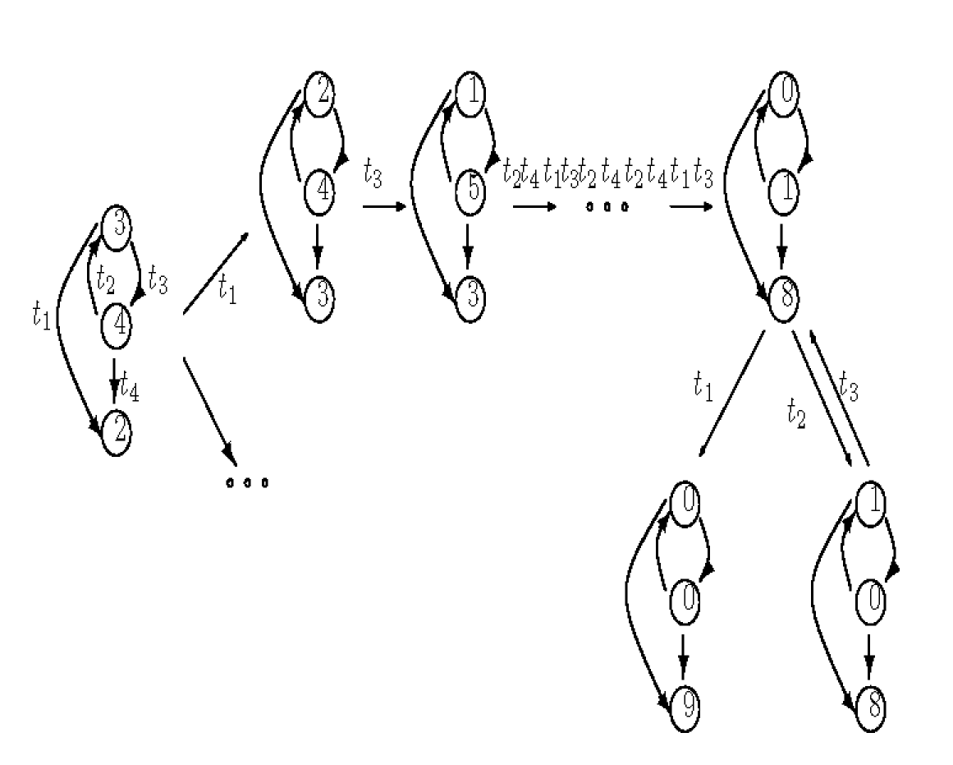
Fig. 2. Some configurations of a CCFG with 9 chips.

First of all, we present here some preliminary definitions.
Definition 1: Let T = (V, E) be a rooted tree with V = {1, ... , n}, a node is a vertex of T, a leaf is a node having no child, and the depth of a node v, denoted by d(v), is the length of the unique path from the root to v.
Definition 2: Let n be a positive integer and let S be a set with |S| = k. A composition of n into S is an ordered sequence (a₁, a₂, ..., a_{k}) of non negative integers such that a₁ + a₂ + ... + a_{k} = n. The integer a_{i} is called the weight of i.
Next, we define for each composition a of n into V, the horizontal energy as follows:
Definition 3: Let T = (V, E) be a rooted tree and let a = (a₁, ..., a_{m}) be a composition of n into V. The horizontal energy e_{H}(i, a) at node i of a is the quality a_{i}d(i). And the horizontal energy of a is the quality .
Now, the CCFG on T with n chips, denoted by CCFG(T,n), is defined as follows:
- Each configuration is a composition of n into V;
- In the initial configuration , all n chips are centered at the root, and there is no chip at other nodes;
- Evolution rule: the node i can give one chip to the node j, one of its children, if i has at least one chip.
We denote also the configuration space of this game by CCFG(T, n), and we write b ≤ a if b can be obtained from a by a firing sequence. In particular, we write a → b if b is obtained from a by applying once evolution rule. It is clear that e_{H}(b) = e_{H}(a) – 1. This implies the following result.
Lemma 1: The configuration space CCFG(T, n) has no cycle and consequently it is stationary. Moreover, the set CCFG(T, n) equipped with the relation ≤ is a poset.
Figure 3 shows an example of a CCFG on a tree of 5 nodes with 2 chips.
In the next propositions, we give a characterization of configurations of CCFG(T,n) as well as its fixed points.

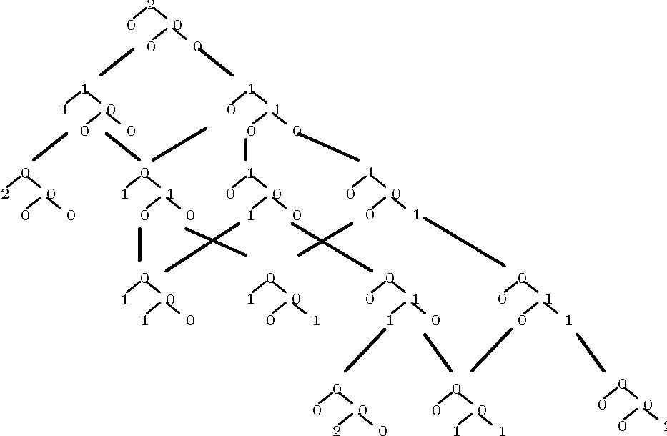
Fig. 3. The conﬁguration space of a CCFG on tree.

Proposition 2: The set CCFG(T,n) is exactly the set of compositions of n into V. Consequently, CCFG(T,n) has exactly conﬁgurations.
Proof: Let a = (a₁,a₂,... ,a_{m}) be a composition of n into V. It is clear that if e_{H}(a) = 0 then a have no chips at any node but the root of T, that means a is nothing but . In the case e_{H}(a) > 0, we prove that there exists a ﬁring sequence from the initial conﬁguration  to a. For that, it is suﬃcient to show that there exists a composition a’ of n into V such that a’ → a and e_{H}(a’) < e_{H}(a). Because e_{H}(a) > 0, there exists a node i such that a_{i} > 0. Let j be the father of i. We consider the composition a’ obtained form a by increasing a_{j} by 1 and by decreasing a_{i} by 1. It is easy to check that a’ is a composition of n into V satisfying a’→ a and e_{H}(a’) = e_{H}(a) - 1.
This result implies that the number of conﬁgurations of CCFG(T,n) is the number of non-negative integer solutions of the equation x₁ + x₂ + … + x_{m} = n. Hence it is . The proof is completed.
Then the following result is straightforward:
Corollary 1: The ﬁxed points of CCFG(T,n) are compositions of n into the set of leaves of T. Consequently, the number of ﬁxed points of CCFG (T,n) is , where l is the number of leaves of T.
In the previous section, while studying the general model CCFG, we show a necessary condition by shot vector for two conﬁgurations to be comparable. However, we have not yet given any suﬃcient condition for this. In constrat, withthe support graph beinga tree, we can describe explicitely the order between conﬁgurations by introducing the following notation of vertical energy.
Deﬁnition 4: Let T = (V, E) be a rooted tree and let a = (a₁,...,a_{m}) be a composition of n into V. The vertical energy e_{V}(i,a) at node i of a is equal to the number of chips in the subtree of T rooted at i. And the vertical energy of a is the quality .
We observe that e_{V}(a) = e_{H}(a). Moreover, if the node i has children i₁, i₂,... ,i_{k} then e_{V}(i,a)= e_{V}(i₁, a) + e_{V}(i₂, a) + … + e_{V}(i_{k}, a) + a_{i}. Therefore, each conﬁguration is determined uniquely by their vertical energies at all nodes of the support tree.
We can now state our result on the order of CCFG on tree:
Theorem 1: Let a and b be two conﬁgurations of CCFG(T, n). Then a ≥ b in CCFG(T, n) if and only if e_{V}(i, a) ≤ e_{V}(i, b) for all nodes i of T.
Proof: First, we prove the necessary condition. It is suﬃcient to prove the statement for the case a → b. Assume that b is obtained a by transferring one chip from node i to j. Then a_{l} = b_{l} for all l ≠ i, j. Let k be a node of T. If k ≠ j, then the subtree of T rooted at k contains either both i, j or none of them. So e_{V}(k, a) = e_{V}(k, b). If k = j, then e_{V}(j, a) = e_{V}(j, b)- 1. Therefore, e_{V}(k, a) ≤ e_{V}(k, b) for all nodes k
of T.
Conversely, we prove the suﬃcient condition for showing that there exists a ﬁring sequence from a to b. It is clear that if e_{V}(i, a) = e_{V}(i, b) for all nodes i then a = b. For other cases, we remark that there exists a node i such that e_{V} (i, a) < e_{V}(i, b) and e_{V}(k, a) = e_{V}(k, b) for all nodes tk of the subtree rooted at t. This implies that a_{i} < b_{i}. Let j be the father of i. Let c be the composition of n into V obtained from b by increasing b_{j} by 1 and by decreasing b_{i} by 1. It is easy to see that c → b. So, by using the necessary condition, we have e_{V}(i, c) = e_{V}(i, b) – 1 and e_{V}(k, c)= e_{V}(k, b) for all nodes k ≠ i. Hence, e_{V}(k, c) ≥ e_{V}(k, a) for all nodes k of T. So by recurrence we also obtain an inverse ﬁring sequence from b back to a. This completes the proof.
To ﬁnish this section, we investigate the structure of CCFG on tree. Let us recall that, in the classical model CFG, the conﬁguration space has a lattice structure with a unique ﬁxed point. Unfortunately, in the general CCFG, there are many ﬁxed points in the conﬁguration space and the structure of this space is quite complicate. Nervertheless, in the case the support of a CCFG is a rooted tree, we can prove the local lattice structure. Let us ﬁrst recall that for any two elements a ≥ b in a poset, the interval [b,a] is the set of all elements c suchthat a ≤ c ≤ b.
Theorem 2: Let a ≥ b be two conﬁgurations of CCFG(T,n). Then the interval [b,a] is a graded lattice.
Proof: Since the interval [b,a] has a mimimal element b, to prove its lattice structure it is suﬃcient to prove that for any two elements c,d ∈ [b,a], there exists sup(c,d) (see [17]). To ﬁnd this supremum, we ﬁrst compute its vertical energies as follows. Put e_{i} = min{e_{V}(i,c), e_{V}(i,d)} for every node i of V. It is clear that e₁= n. In addition, if i has children i₁, i₂,...,i_{k}, then
$$e_{i_{1}}+e_{i_{2}}+\text{.}\text{.}\text{.}+e_{i_{k}}$$
$$=\text{min}\left\{e_{V}\left(i_{t},c\right),e_{V}\left(i_{t},d\right)\right\}+\text{.}\text{.}\text{.}+\text{min}\left\{e_{V}\left(i_{k},c\right),e_{V}\left(\text{ik},d\right)\right\}$$
$$\text{min}\left\{e_{V}\left(i_{1},c\right)+\text{.}\text{.}\text{.}+e_{V}\left(i_{k},c\right),e_{V}\left(i_{1},d\right)+\text{.}\text{.}\text{.}+e_{V}\left(i_{k},d\right)\right\}$$
$\text{min}\left\{e_{V}\left(i,c\right),e_{V}\left(i,d\right)\right\}=e_{i}$.
Now, let us deﬁne the following sequence of non-negative integers: g = (g₁,g₂,...,g_{m}) where $g_{i}=g_{i}−\left(g_{i_{1}}+g_{i_{2}}+\text{.}\text{.}\text{.}+g_{i_{k}}\right)$. It is clear that this sequence is a composition of n into V, that means g is a conﬁguration of T. Furthermore, g has vertical energies e₁, e₂,..., e_{m}. So by using Theorem 1, we have g ≥ c and g ≥ d. On the other hand, let h be a conﬁguration of CCFG(T,n) satisfying h ≥ c,d. We have e_{V}(i, h) ≤ e_{V}(i, c) and e_{V}(i, h) ≤ e_{V}(i, d) for all nodes i of T, this implies that e_{V}(i, h) ≤ min{e_{V}(i,c),e_{V}(i,d)}= e_{V}(i,g). Hence g ≤ h. This proves that g is the supremum of c and d.
Finally, we remark that the horizontal energy is reduced by exactly 1after once applying the evolution rule. So the lattice [b,a] is graded.
The following corollary is straightforward from the graded propertyn of the lattice.
Corollary 2: In the CCFG(T,n) we have:
i) The maximal length of a ﬁring sequence from the initial conﬁguration to one ﬁxed point is $n\text{.}\underset{i∈T}{\text{max}}\left\{d(i)\right\}$.
ii) The minimal length of a ﬁring sequence from the initial conﬁguration to one ﬁxed point is $n\text{.}\underset{i∈T}{\text{min}}\left\{d(i)\right\}$.
References
- A. Bjorner, L. Lov´asz, W. Shor, “Chip-ﬁring games on graphes”, E.J. Combinatorics 12 (1991) 283.
- A. Bjorner, L. Lov´asz. “Chip ﬁring games on directed graphes”, Journal of Algebraic Combinatorics 1 (1992) 305.
- M. Latapy, H.D. Phan, “The lattice structure of chip ﬁring games”, Physica D 115 (2001) 69.
- S.-T. Huang, “Leader election in uniform rings”, ACM Trans, Programming Languages Systems 15 (3) (1993) 563.
- J. Desel, E. Kindler, T. Vesper, R. Walter, “A simpliﬁed proof for the self-stabilizing protocol: A game of cards”. Information Processing Letters 54 (1995) 327.
- E. Goles, M.A. Kiwi, “Games on line graphes and sand piles”, Theoret. Comput. Sci., 115 (1993) 321.
- E. Goles, M. Latapy, C. Magnien, M. Morvan, H.D. Phan, “Sandpile models and lattices: a comprehensive survey”, Theoret. Comput. Sci., 2001. To appear.
- E. Goles, M. Morvan, H.D. Phan, “The structure of linear chip ﬁring game and related models”, Theoret. Comput. Sci., 270 (2002) 827.
- C. Magnien, H.D. Phan, L. Vuillon, “An extension of the model of chip ﬁring game”, Discrete Math. Theoret. Comput. Sci., AA (2001) 229.
- N. Biggs, “Algebraic potential theory on graphs”, Bull. London math. Soc., 29 (1997) 641.
- N. Biggs, “Chip firing and the critical group on a graph”, Journal of Algebraic Combinatorics 9 (1999) 25.
- D. Rossin, R. Cori, “On the sandpile group of dual graphs”, European Journal of Combinatorics 21 (2000) 447.
- P. Bak, C. Tang, K. Wiesenfeld, “Self-organizedcriticality: An explanation of 1/f noise”, Physics Review Latters 59 (1987) 381.
- M. Latapy, R. Mataci, M. Morvan, H.D. Phan, “Structure of some sand piles model”, Theoret. Comput. Sci., 262 (2001) 525.
- C. Moore, M. Nilsson, “The computational complexity of sand piles”, Journal of Statistical Physics 96 (1999) 205.
- E. Goles, M. Margenstern, “Universality of chip ﬁring game”, Theoretical Computer Science, 172 (1997) 121.
- B.A. Daveyand H.A. Priestley, “Introduction to Lattices and Order”, Cambridge UniversityPress, 1990.

Corresponding author. E-mail: phanhaduong@math.ac.vn

