Ứng dụng Hệ thống Chuyên Gia cho quản lý tổ chức giáo dục
trong nền kinh tế thị trường và các ứng dụng của nó

Hai Van Pham
(IT Division, College of Education, Vietnam National University Hanoi)
PhD. research from Rits. University, Japan
Email: haivnu@vnu.edu.vn

Tóm tắt

Trong quản lý giáo dục truyền thống, đảm bảo chất lượng và chất lượng đào tạo đóng vai trò quan trọng trong các trường đại học / tổ chức giáo dục dựa vào sự định hướng chiến lược của các nhà lãnh đạo giáo dục. Hệ chuyên gia xem như một công cụ hữu ích hỗ trợ cho đảm bảo chất lượng trong quản lý giáo dục. Để tìm các kỹ thuật trong hệ chuyên gia sẽ rất cần thiết cho xây dựng ứng dụng công nghệ thông tin trong việc nâng cao chất lượng đào tạo của trường đại học hay tổ chức giáo dục một cách hiệu quả. Hiện nay, có rất nhiều các nghiên cứu tập trung vào các công cụ trợ giúp quyết định trong các lĩnh vực kinh tế, thương mại và công nghiệp. Tuy nhiên, rất ít nghiên cứu tập trung trong các lĩnh vực quản lý giáo dục. Ứng dụng hệ chuyên gia giúp các nhà quản lý giáo dục có quyết định đúng đắn trong đánh giá đảm bảo chất lượng và chất lượng đào tạo. Nghiên cứu này đã ứng dụng hệ chuyên gia trong Đại học Quốc gia Hà nội. Theo các phản hồi của các chuyên gia của trường, ứng dụng mô hình này được đánh giá tính năng hiệu quả cao.

ABSTRACT
AN APPLIED EXPERT SYSTEM FOR MANAGING AN EDUCATIONAL ORGNAZATION IN MARKET ECONOMICS AND ITS APPLICATIONS

In a traditional educational management, training quality and quality assurance have a significant role in universities/ educational organizations based on their educational leadership’s strategies. An Expert System can be a strong technique supporting the quality assurance in educational management. To find out techniques in Expert System is very important to build an IT application for improvement of training quality of university’s / organizations in effectiveness and efficiency. Currently, many studies focus on exploring decision making techniques in many areas such as economics, business, and industry. However, there are few researches focusing on studying in educational management areas. The expert system application helps leaderships to make better decision for evaluation in training quality and quality assurance of educational management. This research is applied for a case study of Vietnam National University, Hanoi (VNU). According to the feedbacks of VNU educational experts, the application model in practice is very encouraging and recommended.

. Introduction
In recent years, information technology (IT) plays a significant role in educational organization, which helps to be effective and flexible in the management. To achieve these goals, many educational organizations wish to change a solution to manage university or school by utilizing Expert System in educational management. Educational leader can choose the right decision to a good quality of learning, teaching, and the skills needed in the labor market future. Leaders can use a DSS application to assist managing university better decisions.
Currently, Vietnam has over 200 universities and colleges training 1,000,000 students. Education occupies financial about 17.1% of government budget expenditures approximately US$1.6 billion. According to the government, educational financial is expected to increase to 20% by 2010 in order to improve the quality of education. Vietnam Ministry of Education and Training (MOET) has allowed responsibilities for all Vietnamese universities in both education and training at the national level since 1990 (Le, 2006). MOET allows universities to control their budgets and self management. According to education regulations of the government, Vietnamese university and college managing boards are managed by a supervisory of MOET.

In Vietnam, some universities and colleges have applied Total Quality Management (TQM) to the administrative aspects of educational management, academic teaching, research, etc. TQM will help the institution meet the needs of customers both inside the university (students) and outside the university (research supporters, alumni, etc). TQM’s purpose is to organize all of its strategy and operations around customer needs so that applying TQM evaluation to improve training quality and quality assurance in university is needed of educational management.

Rationale
Following the rapid development trend of Vietnam’s universities to apply TQM and ISO standards in higher education, the study becomes more important to improve quality in education and training.
The study proposes an Expert System which is used for evaluation of educational management and provides models/techniques to assist decision making in evaluation. Hence, to find out the modeling techniques of Expert System is one of methodologies in this study.
Decision making has significant roles in Decision Support System (DSS) to solve problems in managers’ requirements. In additions, decision making is critically important skill areas for education managers in evaluation and planning strategy (Saaty, 1980). In DSS research areas, decision maker or a group of DSS requires good leadership to be successful.
The analytic hierarchy process (AHP) is a good candidate in decision making of DSS, which was invented by Professor Saaty Thomas L. (Saaty, 1980). AHP models can be solved problems in decision making. Compared with other techniques in decision making of DSS, AHP technique is the way to solve problems in evaluation of educational management.

3. Concepts of Total Quality Management (TQM)

3.1 The History of TQM
TQM is a strategic tool for successful management of organizations (King, 1993). A successful implementation of TQM is to change in organizational processes and measurement strategies in a quality standard. At that time, Feigenbaum founded Total Quality Control (TQC) term in 1956 to integrate some of the key concepts of what today is known as TQM (Feigenbaum, 1956). During the time, several experts (Deming 1975; Crosby, 1980; Juran, 1986; Ishikawa, 1985) have developed various Total Quality (TQ) philosophies that share common characteristics (Deming, 1974). Nowadays, TQM is a very significant standard to use for a variety of fields such as education, industry, finance, etc.

3.2 Fundamentals of TQM
Based on an analysis of organizations, there are some features of successful TQM organization as follows (Myer, 1989):
- To consider an alignment within an internal educational organization
- To extend understanding of the customer and process-oriented basis for quality
- To design teams, with the development and performance management systems.
- To set particularly challenging goals in educational management
- To manage the organization for feedback and measurement

3.3 Total Quality Management (TQM) in Educational Management
TQM is concerned with customer-focused organizational improvement, achieved all activities of groupings of employees at variety of levels in the structure. It is a means of continuously reinventing the system to obtain the goals of educational organization.
TQM is defined as the planned actions that are important to provide the needs of learners. It is a quality system for measuring that education outcomes are provided standard within available resources. TQM also focuses on managing the effectiveness and performance of school or educational organization. In educational management, TQM strategies’ development can be applied to assure an educational quality of outcomes so that most managing goals focus on a way of evaluating the effectiveness of structures and processes required to achieve outcomes.
In applying TQM in educational organization, the evaluation of organizational performance provides some criteria summarized by Nadler (1980):
- Goals: organization achieves its strategic objectives.
- Resource utilization: the organization offers available resources.
- Adaptability: the capacity of the organization to review its performance and match the changing requirements of its educational environment.
Most criteria are primarily concerned with effectiveness and efficiency respectively. TQM and organizational performance are demonstrated in Figure 1 (Alma, 2000):

Continuous Improvement
Goal obtainment
Resource utilization
Adaptability

Effectiveness Efficiency
Figure 1 TQM and Organizational Performance

3.4 . Main functions of TQM in Educational Management
According to Ansrew (2000), main functions of TQM in educational management are as follows:
- Quality is conceptualized as customer/learner goals
- A customer/learner receives a product or service in an organization.
- The purpose of customer/learner’s needs is defined by the requirement.
- Evaluation in each process in results is needed by customer/learner.
- TQM requires all organization members in quality, performance and improvement.
- Quality information systems are provided to measure of TQM feedback.
In educational management, educational organization describes as an open system in order to improve education quality identified by Katx and Kahn (1996). TQM proves the key success factor for institutions.

3.5. TQM Framework of Educational Organization (School/ University)
TQM framework of educational organization is based on PDCA Model shown in Figure 2.

Act
Plan
Do
Check

Figure 2 Plan, Do, Check, Act - PDCA Model
The general framework explanation is as follows (Ralph, 1997):
- Plan: It is to focus on information needs, what are the results and information needs.
- Do: It is to implement of a small-scale change or test as a pilot for data answer.
- Check: The effects on assessment and measurement for a changing or testing
- Act: The data confirmation in the intended plans, variables, risks in the progress are based on the final step.
The model for continuous improvement developed by Shewhart, after that the implementation part was developed by Deming is Plan (P), Do (D), Check (C), and Act (A) (PDCA model). This process of the model is a cycle, which is never ended that executes all stages of educational organization (e.g, admissions, registration, student affairs, academic programming, etc) (Ralph, 1997).

4 . Overview of Higher education in Vietnam
Higher education in Vietnam was the same as former Soviet Union education since the 1990s with a multiplicity of small type institutions for teaching and research function. Currently, the training model in higher education is to develop by the economic sectors with many specialized institutions. The type of Vietnamese university is managed directly by Vietnam Ministry of Education and Training (MOET) describing in Figure 3.

Types of Vietnamese Universities

Multi-disciplinary Universities

Private (Non-public)
Universities

National Universities

Regional Universities

Semi-public Universities
People-founded Universities
Private
Universities

Figure 3 Vietnamese University models

4.1 Multi-disciplinary Universities
The new universities consist of two types: regional and national universities. Currently , there are two biggest national universities and three regional universities established in Vietnam. The national universities offer bachelor, master and doctoral programs, while the regional universities offer bachelor, masters and other college-level programs. Vietnam National University Hanoi is the largest university, belonging to multi-disciplinary type of university (Le, 2006).

4.2 Private (Non-public) Education and Training
The development of education and training has very significant role in Vietnam since the government focuses on the educational quality for graduates with higher skills necessary to carry out effectively in labor market. A major reform allows the development of a “non-public” system of education to parallel the public system (Le, 2006).
Three types of non-public educational institutions are as follows (Le, 2006):
- Semi-public university: The facility is owned by the state and managed by a public authority at the central, provincial, district, or commune level, but all operating costs are covered by student fees”.
- People-founded university: People-founded institutions are owned and managed by nongovernment organizations or private associations such as trade unions, cooperatives, youth organizations and women’s associations. Operating costs are covered by student fees.
- Private university: Private institutions are owned and managed by private individuals. Fully private institutions are not allowed in primary and secondary education, but only in pre-school, vocational/technical schools, and tertiary education.

The overall Model of Analytic Hierarchy Process (AHP) using TQM Factors
Figure 4 shows the overall model of Analytic Hierarchy Process (AHP) using TQM factors in evaluation of educational management.

Level 1
Objectives
C1
C2
Cn-1
Cn
C’1
C’2
C’n-1
C’n
A1
A2
An-1
An
……….
……….
……….
.
.
.
.
Sub Criteria
Focus

Level 2
Criteria

Level 3
Alternatives

Figure 4 Structure model of the AHP hierarchy

Level 1 – Objectives: Evaluation in training quality and quality assurance using TQM factors of Educational Management in University
Level 2 – Criteria : Include both factors and sub factors analyzed in AHP hierarchy.
Level 3 – Alternatives: Select the best choice decision of the evaluation.

Results and Conclusions
The result of evaluation model is very significant since College of Education (COE), Vietnam National University Hanoi (VNU) based on the development of Faculty of Education (EDUF), VNU, which is a center of quality for undergraduate and graduate training, scientific and technological education research. This is one of the excellent colleges in VNU to enhance education quality of higher education using TQM factors for the international standard. For TQM questionnaire, the answered question in year 2008 has done by the Dean of COE future who is a primary of decision maker in Web-based DSS application. Figure 5 shows the details in an appropriate evaluation model.
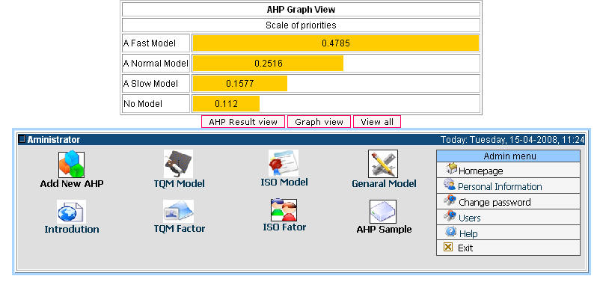

Figure 5 The result of an Appropriate Evaluation Model of COE, VNU
The result can be viewed as AHP graph in Figure 6
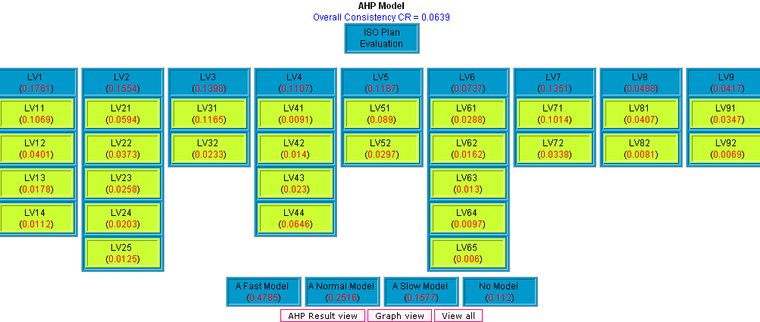

Figure 6 The Appropriate Evaluation Model viewed as AHP graph
According to the result above, the overall consistency (CR = 0.0639) is satisfied. The fast evaluation model is the best choice because of the highest priority (0.4785). The second best choice is a normal model (0.2516), the third choice is a slow model (0.1577) and no model (0.112) is the last one.
As shown in the results above, a fast evaluation model is the best choice to change quickly a strategy in university development with a quick changing model in COE higher education within one year. In this case, it is necessary to drop almost traditional educational management methods. To renew rapidly the teaching, learning methods and total quality management will be focused on TQM model with international standards.
The second best choice is a normal evaluation model within 2 or 3 years. This is to reform the organization combining with traditional educational management based on TQM factors applying in COE.
The third choice is a slow evaluation model within 4 or 5 years since there are many objectives and subjective factors that make renewal process slow. Some educational leaders do not want to adapt with the new model using TQM factors because of difficulty in improvement for all college activities following the international standard.
In conclusion, the expert application helps educational leaders to decide the right decision of their managing organizations.

REFERENCES

Aleamoni, L.M and Spencer, R.E (1973). The Illinois Course Evaluation Questionnaire: a description of its development and a report of some of its results. Educational and Psychology Measurement, Open University Press. 33: p 669-84
Alter and S.L (1980). Decision Support System: Current Practices and Continuing Challenges. Reading, MA: Addison-Wesley.
Bonczek, R.H., Holsapple, C.W. and Whinston, A.B. (1980). The Evolving Roles of Models in Decicion Support System. Decision Sciences, Vol.11, No.2.
Brown Alan and Ton van der Wiele (1996). Australian Journal of Management, © The University of New South Wales Vol. 21, No. 1
Bush Tony, Bell Les, Bolam Ray, Glatter Ron, and Ribbins Peter. (1999), Educational
management in a redefining theory, policy and practice. Educational Management, Open University Press.
Careemers, B.P.M (1991). Schools effectiveness: effective instruction as an imperial contribution to improvement of education in the class room. The Hague: SVO.
Corrigan, J.P. (1994). ISO 9000 The Path To TQM, Quality Progress, vol. 27, no. 5, p33–36.
Crowe J. Thomas and Noble S. James (1997). Architecture of ISO 9000 quality system Standards Multi-attribute analysis of ISO 9000. University of Missouri, Columbia, Missouri, USA.
Deming, W.E. (1996). Out of the Crises, MIT Cases, Cambridge p 89-95
Damrong Thawesaengskulthai (2004). Application of TQM & ISO Concepts for QA System Development in Higher Education of ASEAN University Network (AUN-QA) and CU-QA 84. ASEAN University Network
Ellison B. Davies, (1997). School Leadership For The 21st Century. Educational Management, Cambridge
Feigenbaum A.V., (1956). Total Quality Control, Educational Management, The Open University, Celtic Court 22 Ballmoor Buckingham p93-101.
Golden L. Bruce, Edward A.Wasil, and Patrick T.Harker (Eds.) (1989). The Analytic Hierarchy Process: Applications and Studies . Springer – Verlad Berlin . Heidelberg
Holsapple, C.W. and Whinston, A.B. (1996). Decision Support System: A Knowledge-based Approach. St.Paul: West Publishing.
Harris Alma, Bennett Nigel and Preedy Margaret, 2000. Organizational effectiveness
and improvement in education. The Open University, Celtic Court 22 Ballmoor Buckingham MK18 1XW p114-116
Myer, M.W. and Zucker. L.G. (1989) Permanently Failing Organizations. Beverly Hills, CA: Sage.
Lewis Ralph, and H.Smith (1997). Total Quality in Higher Education. Series Editor Frank Voehl p-85-87
Le Duc Ngoc (2006) Training quality and quality assurance in Vietnam higher education. Ministry of Education and Training Conference - 2006.
Jose L.S. and Herrero, I. (2004). An AHP-based Methodology to Rank Critical Success Factors of Executive Information Systems. Computer Standard and Interfaces. Vol. 28, p5-12
King, J. (1993). Quality Conscious, Computer World, Addison Wesley p89-91.
Keen, P.G.W., and M.S. Scott-Morton (1978). Decision Support Systems, An Organizational Perspective. Reading. MA: Addison Wesley.
Keen and P.G.W (1980). Adaptive Design for Decision Support System. Database, Addison Wesley, Vol.12. No.1 and 2.
Power, D.J. (2002). Decision Support Systems: Concepts and Resources for Managers, Supporting Business Decision Making, Addison Wesley (p 1-4)
Omar E. M. Khalil (2002). Information Systems and Total Quality Management: Establishing the Link. College of Business & Industry, UMASS, Dartmouth.
Saaty.T.L. (1980). The Analytic Hierarchy Process. Mc. Graw. Hill. New Jork
Saul L.Gass (1985). Decision Making Model Algorithms. John Wiley & Son, Inc.
Scott B. Parry (1997). Evaluating the Impact of Training: A collection of tools and techniques. Publishing by the American Society for Training & Development p185
Stephen Murgatroyd and Colin Morgan (1994). Total Quality Management and the School,
Open University Press 22 Ballmoor Buckingham MK181XW p 59-60.
Tayler (2001). Additional Notes dealing with total quality management, EDAS 314 and 414 Leadership and Organizational Effectiveness. Open University Press
Turban, E., Jay E.A and Liang, T.P. (2005). Decision Support Systems and Intelligent Systems, Decision Support Systems: An overview, John Wiley & Son, Inc. (p103-137)
Tribus, Myron (1992). “Ten Management Practices”. In: Voehl, Frank (1992). Total Quality: Principles and Practices with thin Organizations. Coral Springs, p.IV, 19.
Tran Khanh Duc (2006). TQM/ISO 9000 in higher education in Vietnam. Vietnam Ministry of Education and Training Conference.
Roger Ellis (1993). Quality Assurance for University Teaching. The Society for Research into Higher Education & Open University Press. p100-103
Yao, J. T. and Yao, Y.Y. (2003). “Web-based Support Systems”, Products and Services of Web-based Support Systems. Proceedings of the Workshop on Applications
(WSS'03), Halifax, Canada, p1-5.

