PART 1: INTRODUCTION
- Rationale
Information Technology (IT) is a major force that has brought about revolutionary changes in the development of the global, digital society. Education is considered the foundation for development and the concept of IT use in education as powerful tools is strongly encouraged in Vietnam.
The powerful tools which can help teachers to expand the four walls of the traditional classroom and rebuild the class without the walls are increasing in both quantity and quality with the advent of the technology era in the country. Regarding Second Language Teaching, IT has been considered as a tremendous potential tool. IT tools are various from using some popular software in teaching like Power point, Word Processor, Window media to others which are more complex like using Internet, WWW, Webquest, Weblog… to improve the language skills.
Many articles have discussed the effectiveness of IT tools in SLT in the world. However, the application of IT tools in ESL in Vietnam was set forth by Nguyen Lan Trung and Ngo Van Nghiem (1997) who suggested the use of CD-ROM. The recent focus on technology in language study has been on the use of Power point, email and Internet (Nguyen Thu Hoai, 2005; Nguyen Thi Lan Huong, 2004; Pham Thi Ngoc Phuong,2006). The latest focused on the Webquest and Weblog effectiveness in ESP course. In spite of the claimed advantages of these researches, there is a limited number of studies on the developing the Vocabulary Acquisition in ESP course.
These above-mentioned concerns urged the author to carry out the research, called: “A study on the effectiveness of applying IT tools in teaching Vocabulary in English for IT for the second year students at Vietnam – Korea Industrial Technology College (VKITC)”
- Aims of the Study
This study aims to measure the effectiveness of utilization of the class website in teaching English for IT vocabulary for the second year students at VKITC.
Hence, it is expected to achieve the two following objectives:
- First, to investigate the influence of utilizing class website on the vocabulary outcomes of the second year students in English for IT Course at Vietnam Korea College.
- Second, to investigate the learners’ opinions and attitudes towards the application of class website in ESP vocabulary teaching.
- Third, to find out the difficulties students meet during the course.
- Research Questions
In order to achieve the aims of the study, the following research questions were raised:
- To what extent does the employment of class website have influence on the effectiveness of teaching IT vocabulary for the 2nd year students in IT Faculty at VKITC?
- What are the students’ opinions and attitudes towards the utilization of the class website in their IT vocabulary learning?
- What difficulties do students meet during the employment of the class website to improve their vocabulary acquisition?
- Scope of the Study
The present study operates within the following scope:
(i) A study on the application of IT tool in ELT is a broad topic, hence, in this research, the author decides to choose a specific IT tool to study, it is designing a website for the course.
(ii) By the time constraint, making a research with a large number of the participants was out of the author’s reach, hence, the participants for the study was 40 students from 105 students at IT Faculty at VKITC.
- Methods of the study
The method used in this study is quasi-experimental research design which utilizes both qualitative and quantitative data collection techniques. The writer, who created IT Vocabulary Program, designed a website for the class. The data collected for the study is from the pretest and posttest, online survey questionnaires.

6. Significance of the Study
The first significance of the study is for the author herself and for the other ESL teachers in VKITC since the data collected from the study can be analyzed and interpreted in terms of using website to promote the effectiveness of ESP teaching at this College.
The results of the study are also expected to English language teachers who have interest in applying new technology in their classroom for higher teaching quality. Especially, the teachers who are teaching English for IT in colleges or university can use the materials, worksheets, sites in the Nicemoon’s class website (the term “Nicemoon” and the website was created by the researcher of this study) for their teaching with their own teaching purposes.
The last but not least significance of the study lies in the fact that it can lay grounds for further researches on the employment of Website-based activities in ESP as well as in General English teaching and learning.
7. Design of the Study
The study consists of three main parts:
Part one ‘Introduction’ introduces the rationale, the aims, the research questions of the study and the scope, the methods and significance are also presented in this chapter.
Part two ‘Development’ consists of four chapters
Chapter one provides the literature review including the overview of CALL, Incidental vocabulary acquisition, the benefits of the Internet in Second language Education and the World Wide Web as a Second Language Teaching tool.
Chapter two discusses the detailed procedures to the design of the Web-Based Program.
Chapter three details a quasi-experimental research as the method of the study, the participants and the instruments to collect both qualitative and quantitative data.
Chapter four presents results of the study, the findings in which research questions are addressed and implications are also presented in this Chapter.
Part three ‘Conclusion’ summarizes the main issues touched upon so far in the study. Limitation and suggestion for further study are also discussed in this Chapter.
PART B: DEVELOPMENT
CHAPTER 1: LITERATURE REVIEW
This chapter introduces a brief review of the literature relevant to the study and is divided into four sections. The first sections briefs the history of Computer Assisted Language Learning (CALL), the second sections is an overview of incidental vocabulary acquisition, it continues by discussing the benefits of the Internet to second language learning, the last one looks at the World Wide Web as a tool in second language teaching.
1.1. CALL
Since the initial introduction of computers into the field of second/foreign language education, a large number of practitioners have concurred that this technology holds great potential for language learning (Levy, 1997; Muyskens, 1997; Pennington, 1996; Warschauer, 1996; Warschauer & Healey, 1998). This belief leads to what is known as Computer-Assisted Language Learning, more commonly referred to as CALL. Even though the field is still young, many language educators are endorsing its use as an essential component in language teaching. Embracing the use of computers seems to be due to the fact that computers are capable of performing multiple tasks and thus are more than simply text processors. The computer can organize, select, and present multiple sensory components.
Computer-Assisted Language Learning (CALL) is defined as ‘the search for and study of applications of the computer in language teaching and learning’
Among the concerns often raised in the domain of CALL is how to use the potential of a computer to enhance the language learning process and how to use different media types in teaching and learning. The concern has been narrowed to the investigation of the efficacy of presenting information using multiple modalities, such as text, audio, still picture, and dynamic videos in the field of SLA. An area that has recently received attention is the impact of glossing individual vocabulary via annotations embodied by different modes and media. Researchers were inspired by the premise that a variety of glosses for words in various modalities, such as printed text, graphics, dynamic video, and sound, might have differing capacities to facilitate vocabulary acquisition and retention. (Chun & Plass, 1996; Davis & Lyman-Hager, 1997; Lyman-Hager, Davis, Burnett, & Chennault,1993; Martinez-Lage, 1997).
Though CALL has developed gradually over the last 30 years, “this development can be categorized in terms of three somewhat distinct phases which I will refer to as behavioristic CALL, communicative CALL, and integrativeCALL”(cf. Barson & Debski, in press).

1.1.1. Behavioristic CALL
The first phase of CALL, conceived in the 1950s and implemented in the1960s and 1970s, was based on the then-dominant behaviorist theories of learning. Programs of this phase entailed repetitive language drills and can be referred to as "drill and practice" (or, more pejoratively, as "drill and kill").
“Drill and practice” courseware is based on the model of computer as tutor (Taylor, 1980). In other words the computer serves as a vehicle for delivering instructional materials to the student. The rationale behind drill and practice was not totally spurious, which explains in part the fact that CALL drills are still used today. Briefly, according to Taylor, behavioristic CALL:
  - Repeated exposure to the same material is beneficial or even essential to learning
  - A computer is ideal for carrying out repeated drills, since the machine does not get bored with presenting the same material and since it can provide immediate non-judgmental feedback
  - A computer can present such material on an individualized basis, allowing students to proceed at their own pace and freeing up class time for other activities
In the late 1970s and early 1980s, behavioristic CALL was undermined by two important factors. First, behavioristic approaches to language learning had been rejected at both the theoretical and the pedagogical level. Secondly, the introduction of the microcomputer allowed a whole new range of possibilities. The stage was set for a new phase of CALL.

1.1.2. Communicative CALL
The second phase of CALL was based on the communicative approach to teaching which became prominent in the 1970s and 1980s. Proponents of this approach felt that the drill and practice programs of the previous decade did not allow enough authentic communication to be of much value.
One of the main advocates of this new approach was John Underwood, who in 1984 proposed a series of "Premises for 'Communicative' CALL" (Underwood, 1984, p. 52).
Several types of CALL programs were developed and used during this the phase of communicative CALL. According to Taylor & Perez (1989) there were three main types of CALL:
- Computer as tutor
- Computer as stimulus
- Computer as tool or Computer as workhorse
On the face of things communicative CALL seems like a significant advance over its predecessor. But by the end of the 1980s, many educators felt that CALL was still failing to live up to its potential (Kenning &Kenning, 1990; Pusack & Otto, 1990; Roschoff, 1993). The challenge for advocates of CALL was to develop models which could help integrate the various aspects of the language learning process. Fortunately, advances in computer technology were providing the opportunities to do just that.
1.1.3. Integrative CALL
Integrative approaches to CALL are based on two important technological developments of the last decade-multimedia computers and the Internet.
Multimedia technology--exemplified today by the CD-ROM-- allows a variety of media (text, graphics, sound, animation, and video) to be accessed on a single machine.
Computer-mediated communication (CMC), which has existed in primitive form since the 1960s but has only became wide-spread in the last five years, is probably the single computer application to date with the greatest impact on language teaching.
Mark Warschauer stated: “Computer-mediated communication allows users to share not only brief messages, but also lengthy documents and also graphics, sounds, and video. Using the World Wide Web (WWW), students can search through millions of files around the world within minutes to locate and access authentic exactly tailored to their own personal interests. They can also use the Web to publish their texts or multimedia materials to share with partner classes or with the general public”
It is not hard to see how computer-mediated communication and the Internet can facilitate an integrative approach to using technology. The following example illustrates well how the Internet can be used to help create an environment where authentic and creative communication is integrated into all aspects of the course.
Students of English for Science and Technology in La Paz Mexico do not just study general examples and write homework for the teacher; instead they use the Internet to actually become scientific writers (Bowers, 1995; Bowers, in press). First, the students search the World Wide Web to find articles in their exact area of specialty and then carefully read and study those specific articles. They then write their own drafts online; the teacher critiques the drafts online and creates electronic links to his own comments and to pages of appropriate linguistic and technical explanation, so that students can find additional background help at the click of a mouse. Next, using this assistance, the students prepare and publish their own articles on the World Wide Web, together with reply forms to solicit opinions from readers. They advertise their Web articles on appropriate Internet sites (e.g. scientific newsgroups) so that interested scientists around the world will know about their articles and will be able to read and comment on them. When they receive their comments (by e-mail) they can take those into account in editing their articles for republication on the Web or for submission to scientific journals.

1.2. Incidental vocabulary acquisition
Second language (L2) acquisition depends crucially on the development of a strong vocabulary. In the second language acquisition (SLA) subdiscipline known as second language vocabulary acquisition (SLVA), researchers have focused their attention on the need for second-language learners to optimize their vocabulary knowledge (see, for instance, Singleton, 1999; and Schmitt, 2000). In the last five years, the merits of a variety of methods of vocabulary development have been hotly debated, beginning, one might argue, with Nation’s (2001) work. At issue within SLVA has been the relative importance and efficacy of implicit, explicit and incidental learning mechanisms in the acquisition of L2 vocabulary.
Recently, incidental vocabulary learning has received renewed attention within SLVA research. Paribakht and Wesche (1999, p.176) suggest that “incidental vocabulary learning” occurs when “learners are focused on comprehending meaning rather than on the explicit goal of learning new words”. Proponents of incidental vocabulary learning often point to research results that demonstrate vocabulary acquisition in the absence of vocabulary-based directives from teachers or researchers. Often, exposure to vocabulary is thought to be sufficient to trigger acquisition.
Incidental vocabulary acquisition is defined as the “learning of vocabulary as the by-product of any activity not explicitly geared to vocabulary learning” (Hulstijn, 1995, p271). According to him, “picking up” of words and structures, simply by engaging in a variety of communicative activities, during which the learner’s attention is focused on the meaning rather than on the form of the language.
In another words, incidental vocabulary acquisition deals with reading texts or doing activities that are not directly related to learning vocabulary, or the purpose of the task is not made explicit, for example, the learner is given a text (containing new words) to read and told that he/she will be expected to recall the content of the text. The learner is then tested on his/her recall of the new words.
It should be noted that the very term "incidental learning" is open to different interpretations in the literature. In fact, the last few years have seen the blurring of distinction between the incidental and intentional vocabulary acquisition. Traditional studies of incidental vocabulary learning involve learners being told just to read for comprehension, recent twists to the incidental vocabulary learning concept have included more demanding tasks beyond reading such as looking up new words in dictionaries for comprehension (Laufer & Hill, 2000) and recalling and retelling what is read (Joe, 1998).
The present study thus bears a relation to the aforementioned studies. Ellis stated that “the meaning of a new word is acquired totally unconsciously as a result of abstraction from repeated exposures in a range of activated contexts” (Ellis, 1995, p.14). Very recently, the hypothesis has been revised to take into account the incidental learning necessary for the pattern recognition that precedes implicit language learning (Ellis, 2005).

1.3. Benefits of the Internet in Second Language Education
In addition to the communication benefits of the Internet, the Internet can also be used to retrieve and access information. The World Wide Web is therefore a virtual library: it is an available world of information for the language learner. While the Internet offers numerous benefits to language learners and instructors, some are mentioned here in the context of language teaching and learning.
According to Shinghal, one of the most essential pedagogical principles of language teaching is one that emphasizes the study of language in a cultural context. It is believed that language and culture are interdependent. Understanding the culture of the target language enhances understanding of the language. To this end, Shinghal considered the Internet as a valuable resource to both teacher and learner.
Moreover, Shinghal stated that the Internet also serves as a medium for experiencing and presenting creative works. While students can peruse the information on the Net, they can also use it as a platform for their own work such as essays, poetry, or stories. Students therefore become not only consumers of content, but in fact generate the content.
As Mike (1996) describes, the use of the Internet has also been shown to promote higher order thinking skills. A language teacher, for example, may instruct learners to search for specific information. The information must be put together to make a complete and coherent which needs the synthesis process.
Furthermore, the Internet provides supplemental language activities which can provide students with additional practice in specific areas of language learning (Shinghal). These include reading tests and comprehension questions, grammar exercises pronunciation exercises possible through the available multimedia capabilities, vocabulary exercises. Teacher may recommend specific sites on the Web or students can search the Web for the sites.
Although the Internet is a vivid and helpful medium to make language learning more efficient, a successful result depends on how well a teacher implements and integrates it into classroom instruction. It is only due to the teacher’s clear understanding of objectives, planning of coherent activities, searching for relevant resources, creativity that make the Internet-based classes stimulating and valuable.
1.4. The World Wide Web as a Second Language Teaching tool
‘World Wide Web (WWW) represents a new concept in technology, the library on your desktop, the dictionary at your fingertips, the sound at your ear. There is nothing that we hear or see that will not be available through WWW’.
- Sangster, ‘World Wide Web – What can it do for Education?’, Active Learning 2, 1995)
The World Wide Web (or the Web) is one of the most accessible tools available for academics to use. Academics who wish to create simple computer-aided learning courseware often face the decision of whether they should go down the path of learning a multimedia-authoring tool and distributing the material on a CD-ROM or flash disk; or whether they should move to the Internet and utilize the multimedia and creative activities on the Web. They are confused in choosing what to do since using the Web in teaching has many advantages but also some disadvantages.
There are many advantages of the Web, for instance, one has access to a Web server, publication is free, and once published, the material is made available to an international audience amounting to millions. However, accessing on networks is slow, and by opening up access to an international audience there are serious implications for copyright issues, these are some problems of the Web that academics may deal with.
The Web offers various opportunities for the academic who wishes to mount pedagogical materials via the Internet. According to Stuart Lee (2005), one of the best ways to get out of these troubles is creating a class website; this will act as a focal point for students to come to, detailing course time and changes and so on. An example of this is Ms. Feldman’s Class Website at the University of Pennsylvania which details the classics courses she runs there.
Figure 1: Layout of a class website
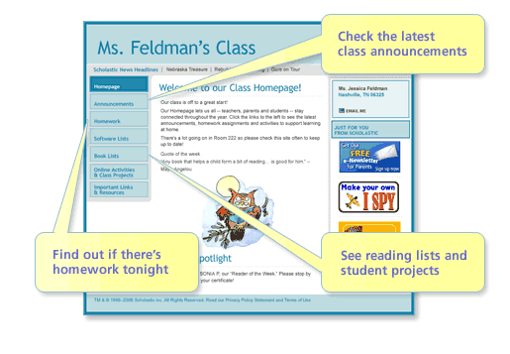
However, the question comes up here is how an instructor can create their own class website to support their teaching while their knowledge of IT is not professional. It would be wonderful if one has good knowledge of HTML to create a class website by oneself. But it is no need to be much worried if one knows nothing about HTML because there are various websites where exist already the form of a class website. What one has to do is to register to be a member and follows the guidelines to create a class website as expected. Here are some addresses that can help teachers to create their class website based on them:
www.scholastic.com
www.teacherweb.com
www.worldchamp.com
www.nicenet.com
www.classnotesonline.com
With the support of above-mentioned websites, what teachers have to do is very simple, they just let the author know their personal information and needs by finishing the registration then they can create their own class websites by themselves with the given form as following example:

Figure 2: Layout of a class website created on www.scholastic.com
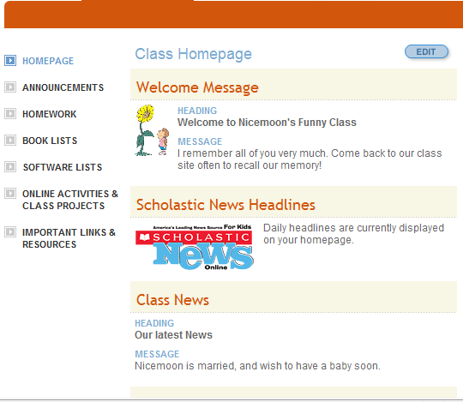

Or you can easily create your own class website by registering and following the instructions given in the website: www.teacherweb.com as the screenshot here:
Figure 3: Layout of a class website created on www.teacherweb.com
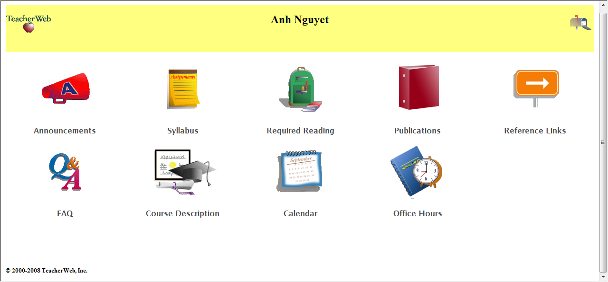

According to Stuart Lee (2005), regardless of your website is created by HTML or in the given form of some above-mentioned address; it is useful to obey the following rules:
- As always evaluate other websites to find out what works and what does not.
- Identify to yourself the goals of the web page
- Plan the site overview on paper (in case the website is created by HTML)
- Select the authentic materials for your website
- Test the site using as many browsers and different specifications of hardware as you have access to.
- Evaluate the Website. This can be done by inviting remote users to look at the pages and to provide comments before trying them out on students.

In short, this chapter has presented the overview of the literature relevant to the study. The focus has been on theoretical background of incidental vocabulary acquisition, a brief introduction of CALL, the discussion of the use of the Internet, especially WWW as tools to promote the effectiveness of vocabulary teaching and learning.
The next chapter will detail the design of Website-based program, that introduce the materials, self-study, etc.
CHAPTER 2: DESIGN OF THE WEBSITE-BASED PROGRAM FOR THE COURSE
This chapter presents the design of the Website-based program for the study. First, aims and objectives of the course are introduced. Next, it explains how the incidental vocabulary acquisition was practiced in the program. After that it looks at the role of the teacher and the students in the course. It continues by discussing about the materials and the worksheets.
2.1. Aims and objectives of the course
The final goal of the program was to offer the students an opportunity to familiarize with the use of the Class Website from which they were exposed to authentic materials available in the Internet.
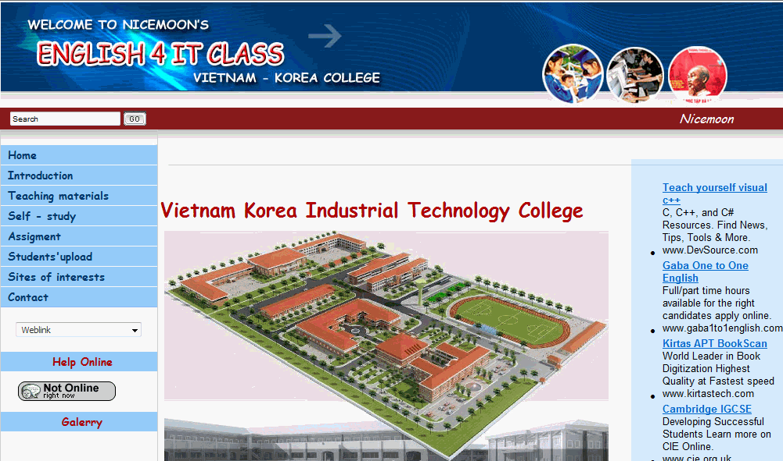
Figure 4: Screenshot of the class website designed for the course

The website: “Welcome to Nicemoon’s English for IT Class”, those who are interested in the website can take a look at the address: www.english4it.vn. When the students got into the Website, they clicked on the page “Introduction”, where the information about the instructor and the objectives of the course were presented as follows:
Figure 5: Screenshot of the page “Introduction”
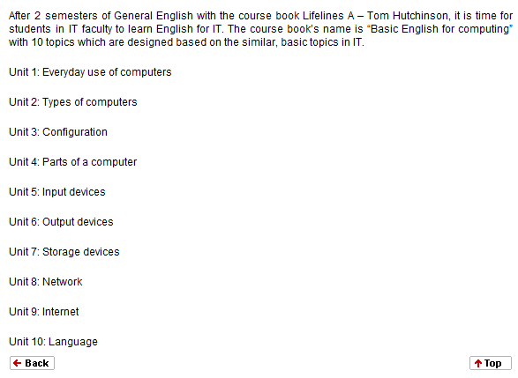

2.2. The English for IT vocabulary teaching Program
The six-week IT Vocabulary Program was designed for the second year students at IT Faculty at VKITC with the support of the class website. For the time constraint, only two lessons are in the experiment time with nine periods for each. They are Unit 5: Input Devices and Unit 7: Storage Devices
There are plenty of authentic materials which some are designed to use online and some are offline. However, materials to teach ESP, particularly English for IT are not very easy for teachers to search and find activities both useful and creative. To this end, the author – the designer of the class website has carefully selected creative activities for English for IT from authentic materials and upload on the class website where are much easier for both teachers and students to access in classroom, no need to jump from this website to another in the class time.
All the materials are divided and arranged based on the topics of the lessons.

Figure 6: Screenshot of the page ‘Teaching Materials/Unit 5: Input Devices’

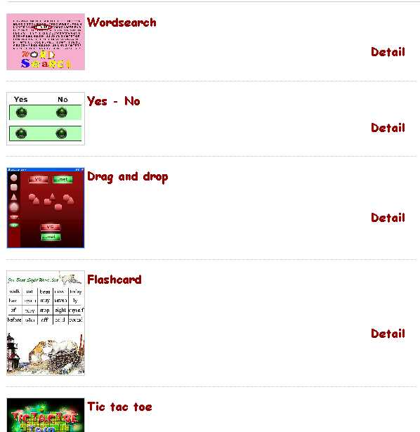

However, teaching a word is not only inside class but also outside class, the above-mentioned part is used online inside the class only. ‘Self study’ and ‘Assignment’ are for outside class learning and practicing.
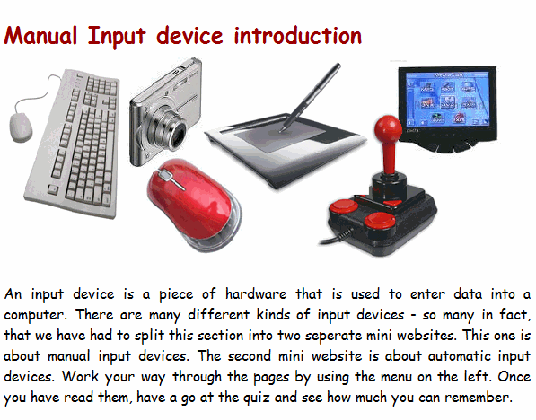
The page ‘Self study’ provides students with plenty of useful information about related topic of the lesson, they can use the vocabulary they have learnt to get the best understanding, by this way, they can use the vocabulary in context correctly. Figure 7: Screenshot of the page ‘Self study’
To practice vocabulary they have learnt, group members download the worksheet from the ‘Assignment’ page from which they individually do first, then members in group exchange and share the ideas to get to the final work which are posted to ‘Students’ upload’ by the group leaders whose the admin passwords for teacher and other groups to check and discuss.
2.3. Role of the Teacher and Role of the Students
In this course, teacher was supposed to be the designer, the instructor and the advisor.
As the designer, she firstly had to think about how the website would be, what the contents would be used, and the teacher herself who finishes the website from its pregnancy up to the now with the help of some friends.
As the instructor, the teacher asked students to group in teams. Each team appointed the team leader who gets the administrator account to post the final team work to the website. This instructor then assigned tasks for teams to complete in given time. The teacher also asked the team leader to take responsibility for the completion of the assignments.

Figure 8: Screenshot of assignment message
As an advisor, the teacher is online at fore set time to help particular work and team work if there is any trouble. She encouraged students to send email to her if they could not online at that time.
Figure 9: Screenshot of Help Online


For the role of the students, they were very active, they worked both in team and in individual. The class were divided into 4 teams, the team leader is the person can get the an admin account with the password to post the final assignment of his/her team to the website.
2.4. Materials and Worksheets
Regarding the fact that not all resources on the Internet are reliable and suitable for the students’ level, materials and worksheets were gathered from authentic websites and carefully selected to post at the class website. The main resources that the materials and worksheets are adapted from are: http://www.teach-ict.com, http://www.britishcouncil.org,
The online teaching materials were selected for a couple of following reasons. First, the materials in form of activities which were designed by IT experts are very creative and interesting, which can not be self-created by the author herself. Second, the textbooks of English for IT available in the market are limited in providing learners with various activities for vocabulary learning.
This chapter has presented the important points in which the Website integrated vocabulary acquisition course was designed. Before the experiment of the course, a great deal of effort was spent to design the Website, the online materials, the worksheets with a focus on two topics: Input devices and Storage devices. The next chapter will present the method of the study.
CHAPTER 3: METHOD OF THE STUDY
This chapter gives a brief overview of quasi-experimental research and then it describes the participants, instruments of the research, including the pretest and posttest, the online survey questionnaire. The procedure of the study is also presented in this chapter.
3.1. Quasi-experimental research
“An experiment can take place only on a laboratory setting with the greatest possible control to study the effects of manipulation” or “any interjection of something different into a natural setting could be considered an experiment”, these are different definition of experiment provided by Hopkins and Antes (1990, p307). According to Nunan (1992, p 24-25), experiments are carried out in order to explore the strength of relationship between variables.
Quasi-experimental research is one of three major types of experiments (pre-experiment, quasi-experiment and true experiment). The word "quasi" means as if or almost, so a quasi-experiment means almost a true experiment. There are many varieties of quasi-experimental research designs, and there is generally little loss of status or prestige in doing a quasi-experiment instead of a true experiment, although you occasionally run into someone who is biased against quasi-experiments. Some common characteristics of quasi-experiments include the following:
- matching instead of randomization is used.
- time series analysis is involved. A time series can be interrupted or non-interrupted. Both types examine changes in the dependent variable over time, with only an interrupted time series involving before and after measurement.
- the unit of analysis is often something different than people. Obviously, any type of research can study anything - people, cars, crime statistics, neighborhood blocks. However, quasi-experiments are well suited for "fuzzy" or contextual concepts such as sociological quality of life, anomie, disorganization, morale, climate, atmosphere, and the like. This kind of research is sometimes called contextual analysis.
Experimental research methods revolve around hypotheses and the final goal of experimental designs is to eliminate alternative hypothesis. The only one difference among these three major types of experiments is that:
Pre-experimental research design may eliminate chance, otherwise eliminates no alternative hypotheses. Quasi-experimental research designs eliminate some, but not all, alternative hypotheses. While true experimental designs attempt to eliminate most alternative hypotheses, especially those related to time and those related to make-up of the groups (selection effects).
There are three types of hypotheses in experimental research methods: Research hypothesis, null hypothesis and alternative hypothesis. Research hypothesis is the first hypothesis the researcher set out about how the results will turn out, it means that there is an effect and it is due to the independent variables.
Then, researchers hold the possibility that there is no effect of the independent variable on the dependent variable on the dependent variable or that the differences observed are due to chance only. This second hypothesis is the null hypothesis. The first step in experimental research, then is ruling out chance. Put another way, researchers set up an experimental design that will allow them to reject the null hypothesis. If they can confidently reject the null hypothesis, then they gain confidence in the research hypothesis.
At this point, another group of hypotheses comes into play, the alternative hypotheses. If there is an effect beyond chance, it may due to the independent variable or it may be due to a number of other factors, so-called extraneous variables or confounding variables. Again, researchers use experimental design to allow them to eliminate alternative hypothesis.
The present study is conducted as a quasi-experimental design. Three hypotheses were set up for the study: The first hypothesis stated in the research questions, the second one was the null hypothesis: There is no difference between the posttest scores of the experimental group and control group. Because this is a quasi experimental research and because of the time constraint, only one the alternative hypothesis was set up for this study: The pretest score of experimental group and control group are different.
3.2. Participants
The participants chosen for the study included 40 IT students in VKITC in their second year. The students were divided into two groups: experimental group and control group with 20 each. These participants were not randomly selected but they belong naturally to two available groups: T8A and T8B, one of which the researcher has been in charge of since the beginning of their second year. The same characteristic of these two groups is that they are both non-major English students. They had finished two terms of English, they studied only one course book “Elementary Lifelines” by Oxford, Hutchinson. Therefore, their English level was elementary. In term three, students moved to learn English for Specific Purposes with the course book “Basic English for Computing” which was designed based on some other course books by the researcher and her colleagues with the aims to make the course book suitable to the English level of students in VKITC.
Among 40 students selected for the survey, the male students outnumbered the female with 29 (72.5%) and 11 (27.5%) respectively. The student gender is illustrated below:
Table 1: Students’ gender
The experimental group studied with the support of Class Website and Power Point Presentation while the control group received paper-based materials and usual mode of vocabulary teaching. The experimental group consists of 20 students, 4 females and 16 males while the control group consists of 20 students, 7 females and 13 males.
3.3. Instruments
To obtain adequate data for the study, the instruments were employed include pretest and posttest, online survey questionnaire.
3.3.1. Pretest and posttest
Pretest and posttest were the same test with different question order, which is administered to both experimental group and control group. The same test was used for both the pre and posttest since this could avoid the fact that the pre-test was more or less difficult than the posttest and vice versa. Moreover, the use of the same test before or after the experimental treatment was to measure exactly the difference that may have been caused by that treatment, and to minimize the possible effect of test familiarity on the students’ gains between the two test administrators. The test was the collaborative work of the researcher and her colleagues at VKITC.
As regards to the content, the test consists of four main parts.
The first and the second part included twenty-two pictures familiar with IT students, and students have to guess which picture goes with which word. The aim of this section is to test students’ ability to guess vocabulary from their IT knowledge.
The third part is to check students’ IT knowledge in accordance with English knowledge.
The last part is ‘Using contexts for vocabulary’; there were four short passages with eight vocabulary gaps. In this question, context clues might help students to determine the meaning of unfamiliar words and then to choose the best answer. The questions sometimes requires only knowledge of dictionary definition, sometimes the understanding of a particular meaning in a particular passage, but sometimes it asked for the meaning of an illustration, example, or concept.
The results of the pretest and posttest are statistically analyzed to measure the effectiveness of the web-based program in comparison with the traditional paper-based method.
3.3.2. An online survey questionnaire
The online survey questionnaire designed for students consists of eighteen questions. The aims of this questionnaire are to investigate the students’ opinions and attitude towards the application of class website in ESP vocabulary teaching, and to investigate the difficulties that students had to cope with during the web-based program learning.
The online survey questionnaire which was published on the address: http://www.esurveyspro.com was administered to the experimental group. The questionnaire is also posted up to the class website where students can make the link more easily:
Figure 10: Screenshot of questionnaire link from class website


The questionnaire consisted of eighteen questions which were divided into two parts. The first one included twelve questions with eleven closed-end questions and one open-ended question, its aims were to investigate the students’ attitudes towards the web-based vocabulary teaching program and their opinions on the effectiveness of the use of class website in teaching English for IT vocabulary in VKITC.
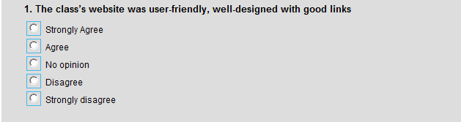
Eleven closed-end questions were designed using 5-point scale as below:


The open-ended question was designed to get students’ advice and comment for the better use of the class website as exemplified below:
The second part of the questionnaire included six questions (from question 13 to 18) which aimed to clarify the difficulties that students faced to when learning with the web-based program, in which question from 13 to 17 are closed questions as the screenshot shown below:

An open-ended question was designed for students to expose their other difficulties that they met during the course. The question is in the form as sample below:


3.4. Procedure of the Study
The procedures of the study are as follows:
- The subjects of the study were selected.
- The experimental group and control group were divided
- Pre-test was administered to the two groups
- The class website was introduced to the experimental group.
- The experimental group began to learn with the support of the class website, the control group started the normal schedule with the paper-based contents.
- Posttest was administered to the two groups.
- Online survey questionnaire was administered to the experimental group
- Results were collected, analyzed and conclusion and implications were done.

This chapter has discussed a quasi-experimental research as the method of the study. The details of the participants, data collection instruments are also presented. The next chapter will present the findings of the study and discussions.
CHAPTER 4: FINDINGS AND IMPLICATIONS
This chapter reports the findings and the discussion based on the data collected from the pretest and posttest, the online survey questionnaire. Research question 1 was addressed by the statistical analysis of the scores of the pretest and posttest. Research question 2 used the results from the part one of the online survey questionnaire. The rest part of the online survey questionnaire was for the answer of the research question 3.
4.1. Findings
4.1.1. Research question 1
The statistical analysis of the pretest and posttest scores (see Appendix 3, 4) was aimed to answer the research question 1:
- To what extent does the employment of class website have influence on the effectiveness of teaching IT vocabulary for the 2nd year students in IT Faculty at VKITC?
We took into account the level of the control group and the experiment group with the help of pretest scores which provided the baseline data for the comparison of posttest scores of the control group and experiment group. The posttest scores comparison of the two-mentioned group would determine the effectiveness of the program on the 20 second-year students.
In order to justify which group would start at higher level, two-tail t-test was used. The pretest scores of the two-mentioned groups were computed and the table below shows the results:
Table 1: Result of t-test for comparison between pre-test scores of experimental group and control group
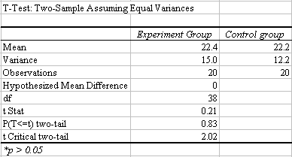

The table shows that the mean 22.4 of the experiment group and 22.2 of the control group were statistically insignificant at p<0.05 level, as the value of t (0.21) is smaller than the Critical value t_{cri} (2.02) and value p (0.83) is more than 0.05. Hence, it can be concluded that the experimental group and the control group had the same starting level of vocabulary acquisition.
It refers to ‘t-test’ as a popular procedure to analyze the difference between two groups on a specific characteristic. In the present study, the author would like to test if the posttest scores of the experimental group are different from those of the control group. Hence, the t-test for independent samples was chosen.
As stated in the 4.1, the null hypothesis is repeated here for convenience: There is no difference between the posttest scores of the experimental group and control group. This null hypothesis will be “rejected if the obtained t value is less than the lower criterion value or greater the upper criterion value” (Hopkins and Antes, 1990, p428).
The value p can be 0.05 or 0.01, but the p value in the present study was 0.05.
Descriptive statistics was computed by using SPSS version 15 for the pretest and posttest of the two groups. And the results of the pretest and posttest scores are in the following table:

Table 2: Descriptive Statistics for Pretest and Posttest Scores of Control Group and Experimental Group

(N = Number of subject)

As we can see from the table, there is an overall increase in the means of the posttest scores. Although both groups started at the same level of incidental vocabulary acquisition ability in the pretest, students in experimental group got a bigger standard deviation (SD=3.872) than students in control group (SD=3.498) which means more students in the treatment group scored towards one extreme or the other than those in the control group did. After the course, the standard deviation of the experimental group (SD=3.761) and the control group (SD=3.748) were quite close to each other. Moreover, the mean of the experimental group’s posttest was 31.40 with the scores ranging from 25 to 38; while the mean of control group’s posttest was 25.05 with the scores ranging from 19 to 32. This indicates that the positive influence of the Class Website-based Vocabulary Teaching program.
To evaluate the effect of the treatment, two-tail t-test was used to compare the posttest mean scores of the experimental group and the control group. The results are detailed as in table below:
Table 3: Results of t-test for comparison between posttest scores of experimental group and control group
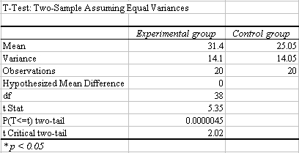

As can be indicated from the table, the mean score of the experimental group is higher than that of control group. The value t (5.35) is bigger than the critical value t_{crit} (2.02) and the value p (0.0000045) is less than 0.05. It can come to conclusion that there was a statistically significant difference between means of the posttest of the experimental group and control group. Therefore, the null hypothesis is rejected; it means that the treatment was effective. In other words, the employment of the class website in E for IT vocabulary teaching was more effective than the traditional paper-course for the second year students at IT Faculty at VKITC.
Chart 2: Pretest and Posttest Mean Increase
The chart shows that the middle scores increased more significantly after treatment in comparison with the non-treatment group.
However, if there is an effect beyond chance, it may due to the independent variable or it may be due to a number of other factors. In this case, these results may due to the different starting level of English proficiency of the experimental group and control group. The alternative hypothesis for this study was: The two groups had started with the same level of English. This alternative was totally eliminated based on the result of pretest scores of the two groups which was shown and discussion above.
In short, the use of class website as supporting web-based tools in this English for IT Vocabulary teaching program has better influence in improving the students’ vocabulary acquisition than the paper-based vocabulary teaching program in VKITC.
In other words, this study has provided a strong case for the conclusion that the web-based program has positive effect on the students’ vocabulary acquisition. Students who participate in the web-based program will be likely to make more progress in their reading proficiency than those who just follow the paper-based program. Up to now, the answer proposed above to the first question can be said to have been confirmed.

4.1.2. Research question 2
2. What are the students’ opinion and attitude towards the utilization of the class website in their IT vocabulary learning?
To answer this question, the results from the online survey questionnaire administered to the experimental group are analyzed.
Question 1 was used to know whether students could use and navigate the website easily and the graphic interface was user-friendly and well-designed or not. The results show that nearly all of the students (95%) agreed that the website was well-designed with good links.
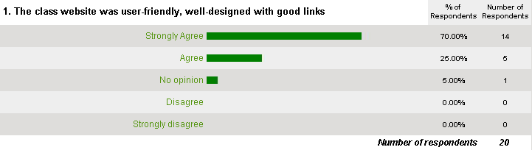
When designing a website, Graphic User Interface (GUI) is very important, but the utmost feature that makes a website become successful and meaningful is nothing but the contents of the website. That is also the aims of the second and third questions.
The responses of the question two show that most of students (90%) found the contents in the website was plentiful, one student (5%) expressed no idea about this, and one students thought that the content was not plentiful enough for the students.
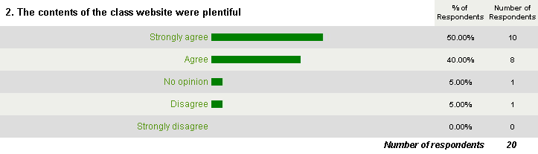
17 students (85%) agreed that the contents of the website exposed them creative activities and they are suitable to their English level, in which 55% strongly agreed about this. No one responded negatively on this question and 3 students (15%) had no idea.
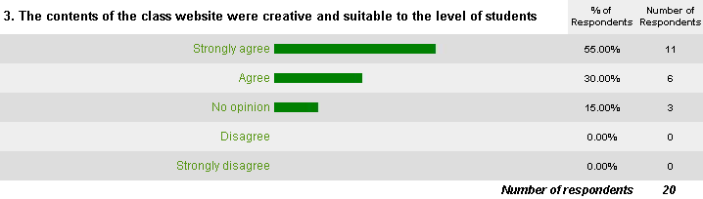
When knowing students' opinions about the GUI and the contents of the website, it is time to investigate students' attitudes towards the website's usefulness. Question 4 was designed to serve this purpose. The data collected show that almost all students (95%) students found the website useful for their study, in which 16 students found it really useful for learning. No one rated the website was useless, only one expressed on idea about this.
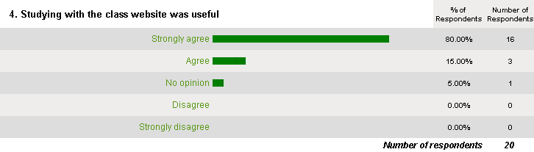
Question 5 and 7 were aimed to explore students' attitudes towards the activities in the website. Question 5's results reveal that 18 students (90%) enjoyed the teamwork for the purpose of the learning, 5% had no opinion whether they liked or disliked, and 1 student (5%) disliked teamwork to learn English because it wasted time.
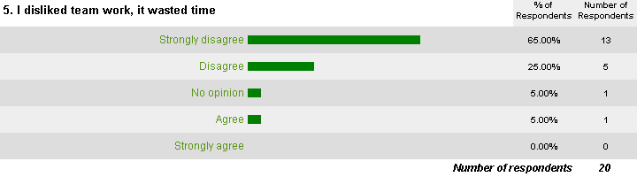
The responses from question 7 were very positive when 95% of the students liked learning with the support of the online activities in the class, in which 70% agreed strongly, only 5% had no idea, no one had unfavorable rate .
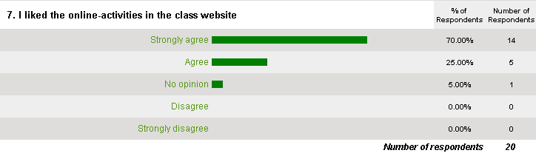
To explore students' satisfaction with the use of class website in the course, question 6 was designed to get the details. The results show that the overall program was very favorably rated by the students; nearly all of the students (95%) agreed that they were generally satisfied with the program. Only one student (5%) had no idea in this regard. This result supported the statistic significance and proved the success of this web-based program.
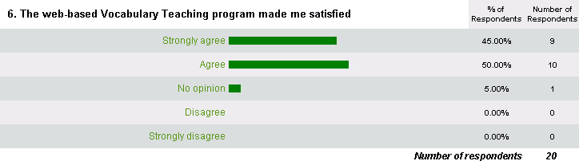
Question 8 and 9 were aimed to explore students' opinion about whether they can improve not only English proficiency but also their IT knowledge through this web-based program. The results received from question 8 show that 19 students (95%) had an opportunity to improve a little bit their knowledge of IT through this web-based program; only one student (5%) once again had no idea about this.
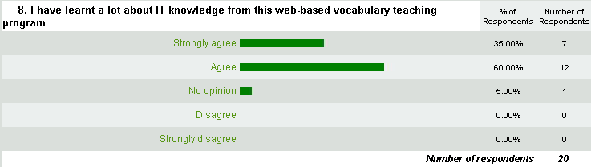
Except the fact that 2 students (10%) had no idea, up to 90% found themselves motivated more when they learned with the class website in the web-based program.
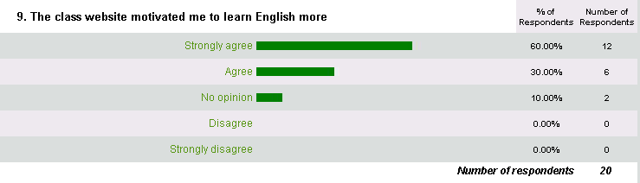
With regards to effectiveness of the program, question 10 and 11 were designed to explore students’ evaluation. Responses to question 10 and 11 disclosed nearly the same positive results where 85% of the students disagreed with the statement that there caused no difference between learning English with or without class website, 15 % of whom had no idea.
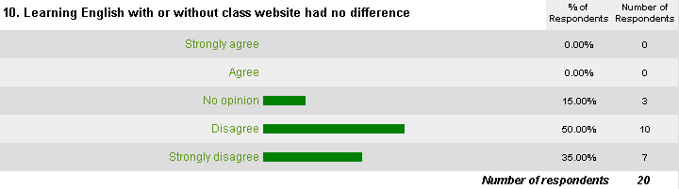

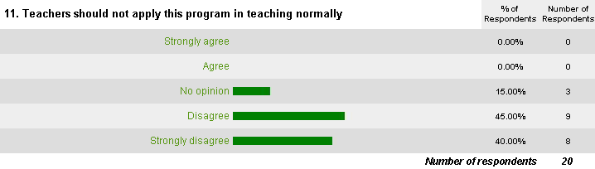
In regard of the students’ suggestion for better web-based program in the future, the answer for question 12 were various and some of them are very useful. Some students suggested that teacher should give more assignments that require them to work in group and use the Internet to search information for their assignments. Another suggested that teacher should spend more time to chat online with students in order to help them solve some problems they cope with the assignments for better result of the group work. Others suggested that teacher should provide them some more useful links that help them learn by themselves.
The first noticing finding after tallying the responses was that most of the subjects agreed that the web-based training were really useful and gave them more pleasure in their study and that they would like to continue such a program in the future. This finding gives further support to the assumption that the web-based program will help to motivate students in learning. Although this web-based program was first applied in VKITC, it was welcome by the students, which laid the foundation of the future program.
This questionnaire also revealed that the majority of the subjects found their knowledge of IT, their English knowledge improved thanks to the web-based program. The analysis and the synthesis of the scores of the tests of the two groups showed that the experimental group made a better improvement in vocabulary acquisition. The pretest scores comparison analysis of the two groups helps to strengthen the conclusion that the improvement made by those who had participated in the web-based course was not due to the chance factor.
Although these findings were not persuasive enough to confirm the effect of the web-based program in teaching and learning English for IT vocabulary, they were noticing in the way that they have given an explanation for the surpass of the posttest.
4.1.3. Research question 3:
- What difficulties do students meet during the employment of the class website to improve their vocabulary acquisition?
The same questionnaire with the questions from 13 to 18 with the aims to discover the difficulties that students meet in the web-based program, the difficulties the author wanted to focus on are the internet skill, team cooperation, the cost of getting online for learning activities and others.
The students for the course are IT students, they are quite familiar with the Internet and its applications in teaching and learning, that can be the explanation why 14 students (70%) found that the web-based program offered them no difficulties in terms of the Internet skills. However, (30%) got in trouble with the Internet skill when they followed this Web-based program.
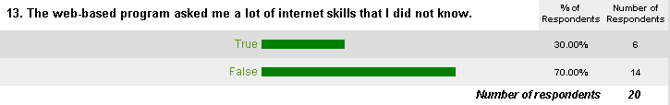
Question 14 checked whether students had trouble working in team outside the class time during the program. In previous English course, students were familiar with teamwork inside the class only; teamwork outside the class time was quite new to them. Thus, 55% found it difficult to do the teamwork outside the class time, but 45% had no trouble with that.
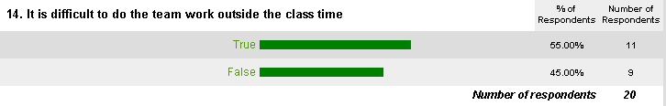
The responses to question 15 reveal that over half of the students (55%) found it uncomfortable doing assignment on the web with longer time. However, 45% had no trouble with that.
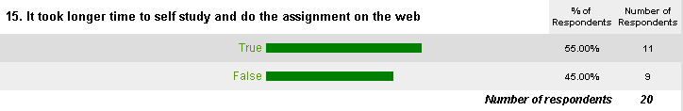
Another problem that students had to face is the cost of getting online. In VKITC, there is a library with about 20 computers connected with the Internet on the ADSL line. However, not all of them can work well all the time, and the ADSL sometimes out of work. That is why up to 35% complained that they spent a lot of money studying in this program.

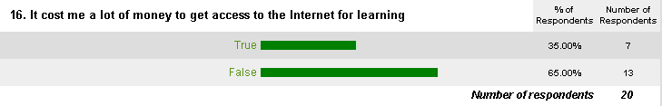
This website is in the experimented time, thus, the author could just plan for two lessons studying only. Question 17's aim is to check whether students continue applying this website and the links in the website to expand their further studying as well as to support their lessons with other topics. The data shows that 6 students (30%) will stop and 14 students (70%) will continue. This demonstrates that the program had some good impact on the learning styles of the students.
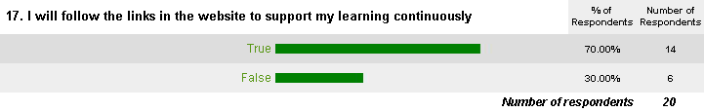
Open-ended question 18 asked students to state other difficulties they had during the course but not listed in the questionnaire. Not all students gave the answer for this open-ended question (only 40%). Some students had trouble with the Internet while they are learning on the web, suddenly the Internet is out of work, they had to stop their learning and wait for another time.
Through the responses of the questions from 13 to 18, it has been found that most of the participants did not have trouble with the Internet skill because they are learning in the IT faculty. And the fact that there is a library with more than 20 computers connected to the Internet help students spend little money for learning online. Working in team outside class is a new way of learning that the participants first try, and that is the reason why more than half of them found it difficult to take the best advantages of the team work. Although they had to face to some troubles for the first time of learning in a new style, 70% would use this website to support their learning in the future by following the links provided in the website. It would be great if the website is designed with the complement of the contents, it means that it does not consist of only two lessons but consist of all the lessons in the course book. This is the limitation of the study which will be mentioned in Part three.
This chapter has discussed the findings of the study in which research questions have addressed. The statistic analysis and the online survey questionnaire analysis show the positive result of the website-based program designed for second year students at IT faculty at VKITC.
4.2. Implications
The findings of the study imply that the class website can serve as an effective tool to help English for IT vocabulary teaching and learning in VKITC. However, technology is merely a tool, not a method, so it should be used to serve the purpose of teaching and learning.
As this website-based project has proved in this study to be effective in improving students’ vocabulary acquisition, it is advisable for it to be introduced widely at the college and at difference language proficiency levels. However, the teacher is advised to be considerate and flexible in designing a website-based program for his/her students.
Whatever the design may come out, the following factors should be observed to make sure that such a program comes into effect:
First, it is necessary to analyze students in terms of their English proficiency levels, and needs. Students also need to have certain knowledge of IT, as in the present study, the subjects are students of IT faculty; they surely have basic computer skills and Internet skills as well.
Secondly, the program needs to be well-designed in terms of its aims and objectives which should be clear to the students at the beginning of the course.
Nowadays, there are some websites that help teachers to create their class website easily with some short steps such as: www.scholastic.com or www.worldchamp.com, www.nicenet.com, www.classnotesonline.com, etc. However, it is advisable for teachers to take a careful look all to decide which can help them create a class website as their needs for the course. If they are not satisfied with the given form of the website, they can create a class website by their own or with the help of IT web designer, free hosts can help them to post their website to the world, or they can spend some money to possess an own host for their website, which can help teaching and learning better because of faster accessing to the website
However the class website creating option is selected, the teacher-designers should follow some useful points below:
Website’s title: Make sure the title of the class website is related to the course and the students who are to going to be the users.
Website’s menu: Make sure the menu is created in a suitable way which can help students understand what they are going to navigate the web.
Content: Make sure the activities are appropriate and help students to learn and use English.
Design effectiveness: Make sure the website is user-friendly and well-designed, which can help students not to be confused when accessing the web.
PART C: CONCLUSION AND IMPLICATIONS
- Conclusion
In the present study, the author has conducted as a quasi-experimental research which apply Internet-based tool – Class website to enhance the effectiveness of English for IT vocabulary teaching at VKITC. The study was carried on 20 second-year students in IT Faculty. The findings show that there was a statically significant difference in mean scores of the posttest for both control group and experimental group who had started at the same level as the pretest scores indicated. This means that the students who participated in the web-based program made more significant improvement in their vocabulary acquisition compared to those who took part in traditional paper-based group. The online survey questionnaire provided the favorable responses of the students toward the Class website which strongly supported the findings.
However, the statistically significant difference could not be enough to come to conclusion that the web-based program is much more effective than traditional paper-based program, because it is this research’s limitation in terms of sample size and other uncontrollable variables. But the significance of the findings lies in the fact that students had favorable attitudes towards the web-based programs which motivated them during the study, and partly contributed to better performance in their posttest.
Moreover, the study also provides information related to problem faced by the students during the experiment of the web-based program. Consequently, these problems will be considered in the future researches in the field.
The results of the study lay foundation for further research in a wider range of population and varying English proficiency levels. The study is hoped to increase the interest of the use of new IT tools in English Language Teachers for better quality of education in Vietnam.
2. Limitations of the study
Despite the significant findings of the study in terms of students’ improvement in IT vocabulary acquisition and their favorable attitudes towards the use of the class website, it should be admitted that the study has following limitations.
The first limitation is the size of the experiment; the study involved two groups of 40 participants. Therefore, only 20 students received the experimental treatment. Moreover, the experimental subjects’ proficiency levels was at elementary in their second year, this narrow range of students’ level partly prevented us from getting a full idea of the effect of web-based program at varying levels of proficiency. Therefore, we do not know yet whether students at different levels at the college would make any progress if they participate in this program. It maybe more effectively used by more able students in English.
The second limitation is attributed to the subjects’ gender, 72.5% of the subjects are males. Hence, we could not make sure whether or not the similar effect can happen to a wider range of gender.
The third limitation lies in the fact that the web-based program was conducted for a period as short as six weeks with classes held once a week for three periods each time. This time limit made a hedge for the researcher to study the participants’ background such as their personality, motivations and so on. The results gained may due to the fact that students learn their lessons in out-of -class time.
Last but not least, for the time constrain, the website for the course were designed with only two experimented lessons (Lesson 5 and lesson 7) which are not continuously learnt with the lesson 6 in between. This did not make a straight line in creating learning styles for students. It would be better if the author could fulfill the website with all the lessons in the course book before taking the experiment into effect.
3. Suggestions for further research
The findings and limitations of the study indicate some suggestions for further research.
The first suggestion is the application of this study with a bigger sample.
The second, this study can be conducted with varying language proficiency levels.
The third, in VKITC students study General English with the course book: Lifelines - Elementary by Tom Hutchison and English for Specific Purposes, it is the author's expectation to conduct a similar study on General English with Lifeline - Elementary course book with the aim to help students in VKITC learn English better with the new style at the beginning so that they can adapt well with the web-based program when they learn ESP.
REFERENCES
Alexander, I. C., Elena A. D., (2005), “The breakthrough of the Internet to Empower ESP Teaching and Learning at Tomsk Polytechnic University”, Global Journal of English. Education, 9, Australia.
Bowers, R. (2001), “Web publishing for students of EST. InM. Warschauer (Eds.), Virtual connections: Online activities and projects for networking language learners Honolulu, Hawaii”, University of Hawaii Second Language Teaching and Curriculum Center.
Chun, D.M. & Plass, J.L (1996), “Effects of multimedia annotations on vocabulary acquisition”, Modern Language Journal, 80, p.183-198.
Chun, D.M., & Brandl (1992), “Beyond form-based drill and practice: Meaning-enhanced CALL on the Macintosh”, Foreign Language Annals, 25, p.255-267.
David A. Trokeloshvili and Neal H.Jost. “The Internet and Foreign Language Instruction: Practice and Discussion”, The Internet TESL Journal, Retrieved January 10th 2008 from http://iteslj.org/Trokeloshvili-Internet.html
Ellis, R. (1994), The Study of Second Language Acquisition, Oxford University Press.
Felix, U. (1999), “Web-based Language Learning. A Window to the Authentic World. WORLDCALL”, Global Perspective on Computer-Assisted Language Learning.
Hulstijn, J. (1997), “Mnemonic methods in foreign language vocabulary learning: Theoretical considerations and pedagogical implications”. In J. Coady & T. Huckin, Second Language Vocabulary Acquisition (p.203-224), Cambridge University Press
Hulstijn, J., Hollander, M., & Greidanus, T. (1996), “Incidental vocabulary learning by advanced foreign language students”, Modern Language Journal, 80, p.327-340.
Hulstijn, Jan H. (2001), “Intentional and incidental second language vocabulary learning: a reappraisal of elaboration, rehearsal and automaticity”. In Robinson, Peter. Cognition and Second language instruction, Cambridge, p.258-287.
Pusack, J. P., & Otto, S. K. (1990), “Applying instructional technologies”, Foreign Language Annals, 23, p.409-417.
Kassim, H. & Ali, Z. (2007). “The Use of ICT in the Implementation of Student-centered learning” Internet Journal of e-Language Learning & Teaching, 4, Retrieved 19th December, 2007 from http://www.eltrec.ukm.my/ijellt/pdf/HafizoahKassim.pdf
Kenning, M.-M., & Kenning, M. J. (1990), Computers and language learning: Current theory and practice, New York. Ellis Horwood.
Kuang-we Lee, “Energizing the ESL'EFL Classroom through Internet Activities”, The Internet TESL Journal, Retrieved January 10th 2008 from http://iteslj.org/Lee-InternetActivities.html
Kumari, S. (1998), “Teaching with the Internet”, Journal of IT for Teacher Education, 7, p.363-377.
Lai, C.-Cheng. (2006), “The Advantages and Disadvantages of Computer Technology in Second Language Acquisition”, A&M Universtity-College of Education, Houston, Texas, Retrieved 11 February, 2008 from http://www.nationalforum.com/ElectronicJournal.
Laufer.B and Hulstijn. L. (2001), “Incidental Vocabulary Acquisition in a Second Language”, The construct of Task-Induced Involvement Applied Linguistics, p.22-26.
Lee, K. (2000), “English Teachers' Barriers to the Use of Computer-assisted Language Learning”, The Internet TESL Journal, 6,. Retrieved January 29th 2008, from http://iteslj.org/Articles/Lee-CALLbarriers.html
Levy, M. (1997), “Computer-Assisted Language Learning”, Context and Conceptualization, Oxford Clarendon Press.
Loretta F.Kasper. (1998), “Focus Discipline Research and the Internet: Literacy for College ESL Students”, The Internet TESL Journal, Retrieved January 10th 2008 from http://iteslj.org/Articles/Kasper-Focus
Mike. D. (1996), “Internet in the schools: A literacy perspective”, Journal of Adolescent and Adult Literacy, 40, 1-3
Nazli, G. (2005), “Computer Assisted Language Learning (CALL)”, Journal of Language and Linguistics Studies, 1.
Nguyen Lan Trung (2002), "The classrooms of Tomorrow", Ky yeu Hoi thao Quoc te: Giao duc ngoai ngu-Hoi nhap va phat trien, p.61-65.
Nunan, D. (1992), Research Methods in Language Learning, Cambridge University Press.
Nunan, D. (1999), Second language teaching & learning, Boston Heinle & Heinle Publishers.
Pennington, M. (1989), Teaching Languages with Computers, Athelstan
Roschoff, B. (1993), “Language learning and IT: State of the art”, CALICO Journal, 10, p.5-17.
Singal, M (1997), “The Internet and Foreign Language Education: Benefits and Challenges”, The Internet TESL Journal, 3. Retrieved February 20th 2008 from http://iteslj.org/Articles/Shighal-Internet.html
Singhal, M. (1997), “The Internet and foreign language education: benefits and challenges”, The Internet TESL Journal, 3. Retrieved April 30, 2007 from: http://iteslj.org/Articles/Singhal-Internet.html.
Teeler D. & Peta Gray (2000), How to Use Internet in ELT, Pearson Education Limited, Harlow.
Underwood, J. (1984), Linguistics, computers, and the language teacher: A communicative approach, Rowley, MA: Newbury House.
Warschauer M (1996), "Computers-assisted Language Learning: An introduction", In Fotos S. (ed), Multimedia Language Teaching, Tokyo: Logos International, Available Online, Retrieve February 25th 2008.
Warschauer M & Healey D. (1998), "Computer and language learning: An Overview", Language Teaching, 31, p57-71. Available online, Retrieved February 24th 2008.
Warschauer M (1997), “The Internet for English Teaching: Guidelines for Teachers”, The Internet TESL Journal, Vol. III, No. 10, October 1997, Retrieved February 10th 2008 from http://iteslj.org/Articles/Warschauer-Internet.html.
Warschauer M. & Carla Meskill (2000), "Technology and second language learning", In J.Rosenthal (Ed), Handbook of undergraduate Second Language Education, p.303-318, Mahwah, New Jersey: Lawrence Erlbaum, Available online, retrieved February 20th 2008.
Watanabe, Y. (1997), “Input, intake and retention: effects of increased processing on incidental learning of foreign language vocabulary”, Studies in Second Language Acquisition, 19, 287-307.

