List of figures 1

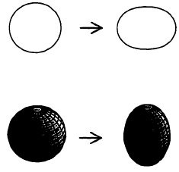

Figure 1.1. Integrable shapes (left) in two and three dimensions and their
non-integrable deformed counterparts [2]

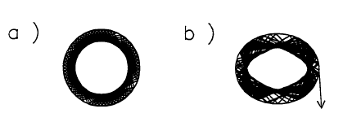

Figure 1.2. Ray trajectories for circle (a), and quadruple-deformed circle (b) parameterized by in polar coordinates for є = 0.08 corresponding to an 8% fractional deformation. Rays are launched from the boundary at the same Φ and angle of incidence sin χ₀ = 0.7 in both cases; ray escape by refraction occurs in case (b)[21]
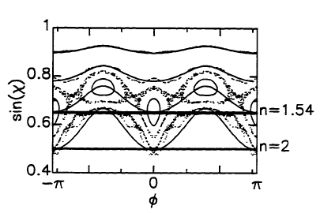

Figure 1.3. The starting condition for the ray escape simulation is given by the adiabatic invariant curve p_{m},_{q-} If tunneling and above-barrier (Fresnel) reflection are neglected, the classical escape condition is that the trajectory cross the line sinχ_{c} = 1/n. This defines a billiard with an escape window in phase space that must be reached by classical time evolution. This window is smeared out when the above wave effects are included.[21]
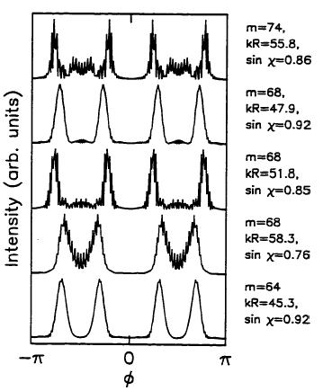

Figure 1.4. Far-field directionality for 5 different resonances of the quadruple at eccentricity e = 0.65 and refractive index n = 1.54, displaying the peak splitting due to dynamical eclipsing.[2]
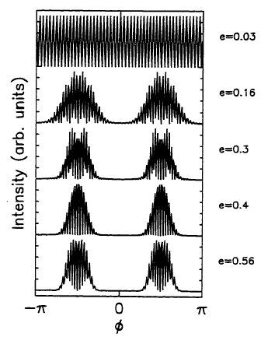

Figure 1.5 . Far-field directionality in the quadruple with increasing eccentricity e at n = 2 for the resonance with m = 45, kR = 27.8 [2]
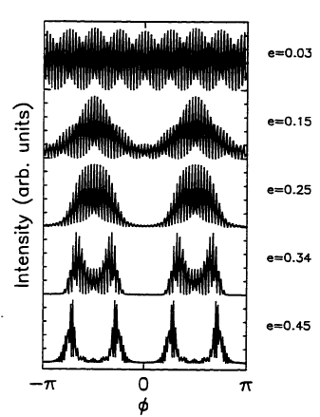

Figure 1.6. Far-field directionality in the quadruple with increasing eccentricity e at n = 1.54 [2]
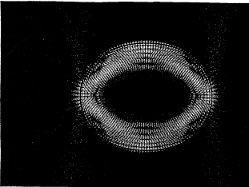

Figure 1.7. Scarred light distribution in a distorted glass fiber cavity [1]
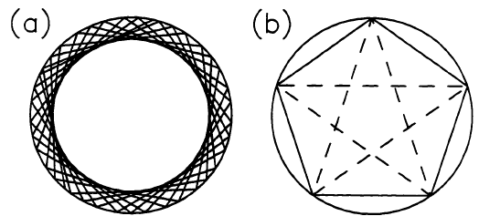

Figure 1.8. (a) A typical quasiperiodic trajectory in the circular billiard
(b) Five- bounce periodic orbits [1]
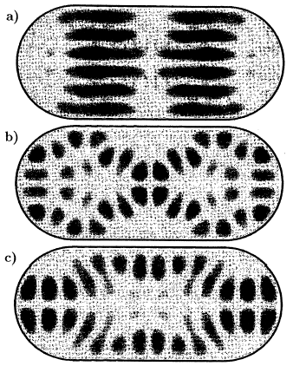

Figure 1.9. Experimental eigenfunstions in a microwave resonator of shape of a stadium billiard. For the display of the wave functions the stadium has been completed by a twofold reflection. All wave functions show strong scarring close to classical periodic orbits.[1]
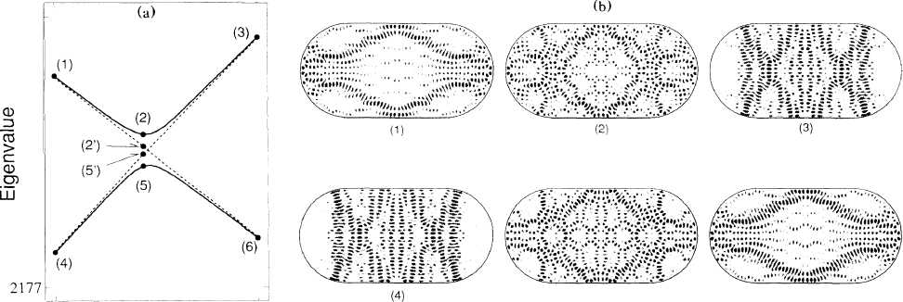
Figure 1.10. (a) Eigenvalues of stadium billiard under variation of the aspect ratio λ as a parameter (solid line), and diagonal elements, a(λ) and b(λ), in the diabetic representation (dotted line); (b) squared absolute value of eigenfunctions around the avoided crossing. These are the 289th and 290th states in the antisymmetric subspace of stadium billiard having the area π+4 [4]

