List of figures 3
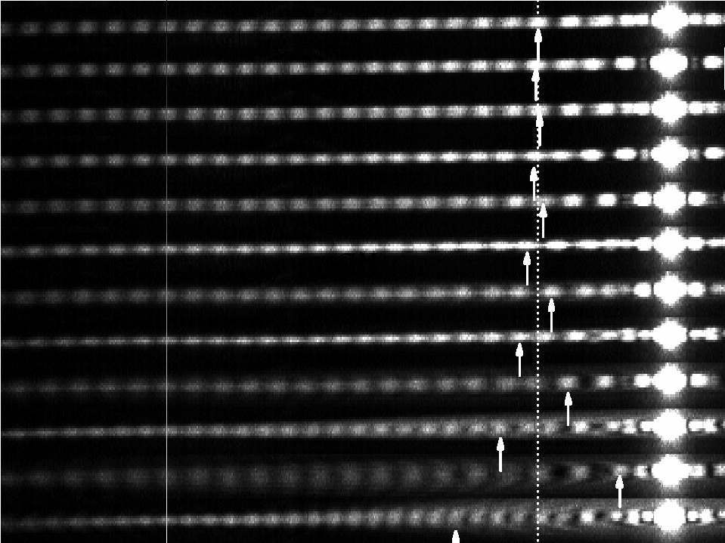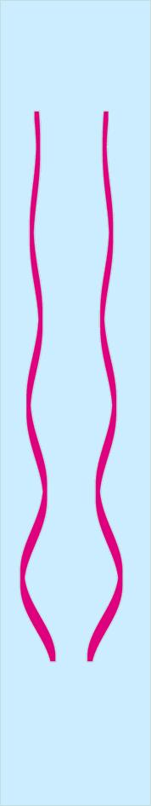
,
orifice
liquid reservoir
(2bar)
250μm
2a₀
a₀η
5
13
9
7
3
11
7
5
3
9
11
13
3
5
7
9
11
13
1
1
1
1
3
5
7
9
11
13
Nonmovable points are
charateristics
of only a quadrupole !

at φ = 0
Ar⁺Laser (514nm)
Diffraction pattern
2r
θ

Figure 2.6. Measure the degree of deformation from diffraction pattern [16]

