Mechanism of forming the Dien Bien basin
Chu Van Ngoi*, Luong Thi Thu Hoai
College of Science, VNU
Received 12 March 2007
Abstract. The Dien Bien basin in the Northwest of Vietnam is the largest one of the pull-apart basins related to the Dien Bien - Lai Chau fault zone. This basin, orientated from the north to the south, is 21km long, 6-8km wide and rhomboidal in shape. The process of forming this basin is related closely to the activities of the Dien Bien - Lai Chau fault zone in Neotectonic time. On analyzing information concerning the kinematics of the Dien Bien - Lai Chau fault zone, the geological structure and the sediments of the basin, we suppose that the Dien Bien basin is a splay pull-apart one related to the movement of the Dien Bien - Lai Chau fault zone in Pliocen-Quaternary time. The determination of the mechanism of forming the Dien Bien basin is important to specify Neotectonic activities of the Dien Bien - Lai Chau fault zone.
Keywords: Active tectonics; Dien Bien - Lai Chau fault zone; Pull-apart basins; Quaternary.

1. Introduction
The Dien Bien basin, 21km long and 6-8km wide, is an important political, economic and cultural center of the Northwest region of Vietnam in general and of the Dien Bien Province in particular. In geological respect, the Dien Bien basin is a small, narrow, rhomboidal pull-apart basin, stretching along the Dien Bien - Lai Chau fault zone, which is more than 160km long, 6-10km wide, and is the most seismically active fault zone in Indochina.
Being an important center of the Northwest region of Vietnam, the Dien Bien basin has been studied in detail for many years. However, the dynamic model of forming this basin is still a knotty question for scientists who study the movement of the Dien Bien - Lai Chau fault zone in Neotectonic time.
In this paper, the authors have analyzed the data about the Dien Bien - Lai Chau fault zone activities, the geological structure of the basin, as well as the theory of basin-forming regime to figure out the mechanism of formation and development of this basin.
2. Activity of the Dien Bien – Lai Chau fault zone in Neotectonic time
During Neotectonics, the geological structure of the Northwest region of Vietnam is controlled by 2 fault zones: the Red River fault zone in the northeast and the Dien Bien - Lai Chau fault zone in the west.
Since Pliocene, the collision of the Indian plate to Eurasia plate had produced a stress field with $σ_{1}$ in N – S direction and $σ_{3}$ in E – W direction [1]. This stress field caused the displacement on all of the active faults in this area.
The Dien Bien - Lai Chau fault zone is one of the most active fault zones in Indochina. This fault zone is a part of the Lai Chau – Luong Pha Bang – Pursat fault system, extending from the border between China and Vietnam from the north, to the Gulf of Thailand in the south. In the Northwest region of Vietnam, this fault is about 160km long and 6-8km wide, orientated north-south, starting from Chieng Chai (Lai Chau) to Tay Trang Pass (Dien Bien) and characterized by left-lateral regime in Pliocene-Quaternary time [1].
Morphologically, Dien Bien - Lai Chau fault zone has en-echelon structure with a major fault in the center of the zone and several secondary faults in the south. The fault zone cuts through Proterozoic, Paleozoic and Mesozoic sedimentary and metamorphic rocks, also Paleozoic and Triassic granitoids. Along the Dien Bien - Lai Chau fault zone, there are some small basins. The Dien Bien - Lai Chau basin, located in the south, is the largest one.
Within Dien Bien basin, there is some olivine basalt exposed along the main fault in Doc Lap hill, Tom village, Muong Thanh airport [2]. The olivine basalt is also found in borehole at the depth of 160m in the central part of basin. This is a product of tectonic activities of the Dien Bien - Lai Chau fault zone in Pliocene-Quaternary time and is one of the bases for determining age of Dien Bien basin.
The movement on the Dien Bien - Lai Chau fault zone also led to form several secondary faults. These secondary faults are expressed clearly in the electronic and seismological cross-sections [3].
The electronic cross-sections show 4 secondary faults in the Quaternary deposits of the Dien Bien basin. They are divided into 2 groups: the first, located near the Nam Rom river bank, is steeper and dipping eastward; the second, located near the basin center, is gentler and dipping westward. Between these 2 groups there is a brittle deformation zone which is subsided and covered by unconsolidated Quaternary sediments.
3. Geological structure and formation of the Dien Bien basin
The geological structure of the Dien Bien basin is composed of 2 main parts: the basement consists of Triassic sedimentary bedrock and the cover consists of Neogene-Quaternary formations. The basin floor has an unsymmetrical "V" shape: the west side is steeper and the east side is gentler.
- The basement composed of conglomerate, gritstone, grading upward to black-grey claystone, siltstone, small-grained sandstone bearing. The bedrock is brittle shattered and pulverized. Some members are folded. According to the electronic and seismological cross-sections, there is a shattered zone developed along the long axis of the basin. The rock of the east side has been broken much more than that of the west side.
- The cover composed of olivine basalt and loose sediments:
+ The Late Neogene basalt erupted as a chain of olivine, pyroxene basalt stretching along the axis of the basin. The sample taken from drill hole shows that the mineral composition of basalt mainly includes olivine and pyroxene, rarely quartz. This basalt has a blue-grey color and is very stable. Its thickness reaches about 100m. When the rock is weathered, the color is changed into red-grey and the weathering basalt layer reaches 2.5-10m.
+ The Quaternary loose sediments are mainly fluvial sediments which are divided into 3 layers. The first one is composed of boulder, pebble, grit mixed with light-grey silt and clay. Pebbles are well rounded and sorted with the main composition of quartz. The second one is composed of pebble, granule, sand and boulder in the low part, silt, clay mixed with some sand layers in the upper part. The last one is composed of pebble, granule mixed with silt and clay.
4. Mechanism of forming the Dien Bien basin
Based on analyzing the activities of the Dien Bien - Lai Chau fault zone and the geological characteristics of the Dien Bien basin, the process of formation of the Dien Bien basin is figured out as follows:
In early Pliocene, as a consequence of the collision Indian plate to Eurasia plate, the South China block was drifted and moved to the southeast as the displacement along the Red River fault and the Indochina block was drifted northward. The Dien Bien - Lai Chau fault and the Sop Cop - Lang Chanh fault were reactivated with the opposite strike slip regime: Dien Bien - Lai Chau fault was left-lateral and Sop Cop - Lang Chanh was right-lateral one, producing an extensional field, associating secondary faults.
The secondary faults played a role of the channel system for the olivine basalt eruption. After the basalt eruption, the weathering process and the subsidence process to form the Dien Bien basin started.
On the west side of the basement, the subsidence may take place so quick that the basement slope is steeper and the bed rock is more stable. In turn, on the other side the bedrock was subsided progressively because it is fairly far the major fault. As a result, the basement slope is gentler. This process formed the unsymmetrical "V" shape of the basement.
As the subsidence processing, the sedimentary process happened and reaches to the sediment thickness of some 5-160m.
The above proofs lead us to conclude that the Dien Bien basin was formed as a Splay pull-apart basin [4].
5. Conclusions
1. The Neotectonic movement of Dien Bien - Lai Chau fault zone and of Sop Cop - Lang Chanh fault plays an important role in forming the Dien Bien basin.

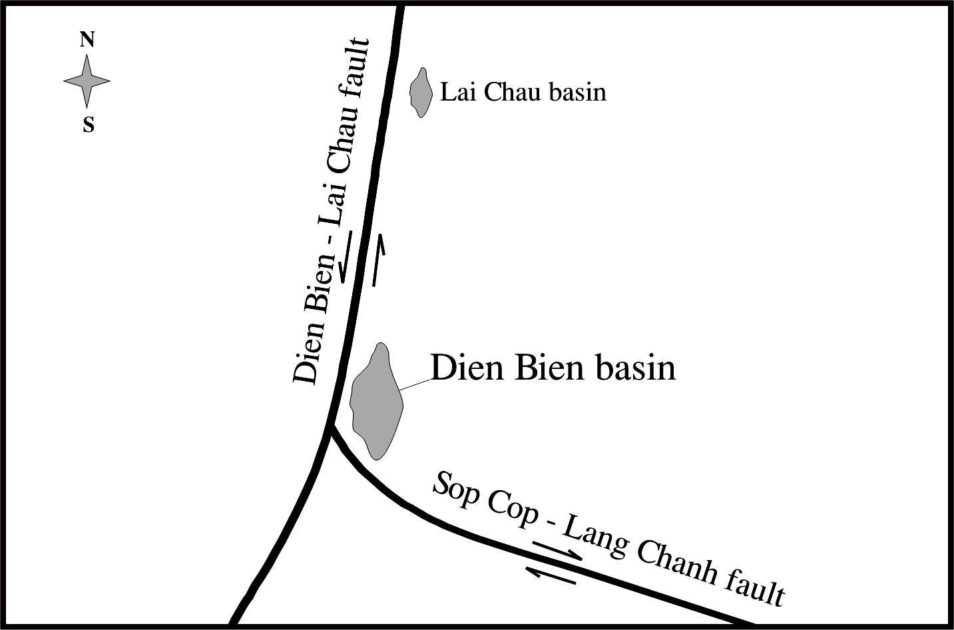
Fig. 1. Diagram illustrating the mechanism of forming the Dien Bien basin.

2. The geological structure of Dien Bien basin is divided into 2 parts: the basement is composed of deformed Triassic sediment; and the cover consisted of olivine basalt and loose fluvial sediment.
3. Morphological structure and the developmental history of the Dien Bien basin clearly expresses that the Dien Bien basin was formed by Splay pull-apart regime.
References
- N.V. Hung, Characteristics of the neotectonic faults in NW Vietnam, Ph.D thesis, Institute of Geology, VAST, Hanoi, 2002 (in Vietnamese).
- Ministry of Heavy Industry, Ministry of Construction, General Department of Geology, Report on investigation of the geological characteristics of Dien Bien City, Hanoi, 1994 (in Vietnamese).
- D.V. Toan, D.V. Tuyen, Applying resistance-electric method on studying geological characteristics in Dien Bien Valley, Institute of Geology, VAST, Hanoi, 2001 (in Vietnamese).
- M. Williams, T. Hathaway, Structural geology workshop, Robertson Petroleum Training Centre, 1997.

Corresponding author. Tel.: 84-4-5587060. E-mail: ngoicv@vnu.edu.vn

