Eutrophycation assessment and prediction
of Bay Mau Lake using mathematical models
Luu Lan Huong*, Trinh Thi Thanh, Nguyen Thi Thanh Nga
College of Science, VNU
Received 22 December 2006
Abstract. The lake ecosystem of Hanoi has a very important role. However, the water quality in the lakes of Hanoi is declining; they're more and more polluted. Among that, eutrophication is the most popular one. Therefore, the assessment and prediction of eutrophication is necessary. One of the effective tools for assessing and predicting eutrophycation is the use of mathematical models. In this paper, we used the Vollenweider model, empirical watershed model and Jorgensen model to determine the eutrophycation of Bay Mau Lake by phosphorous concentration in the lake water.
The results show that Bay Mau Lake is being heavy eutrophication, soluble phosphorus concentration is very high (4.56-7.56mg/l), other phosphorus concentrations is increasing. We had treated phosphorus concentration of sewage before loading to the lake. When Cpl decreases up to 90%, the content of PS fluctuates between 0.49 and 0.9mg/l. This value is much higher than the allowable limit (0.03mg/l). The results of this paper can serve as a base for developing a strategy for protection and sustainable use of valuable water resource.
Keywords: Eutrophycation; Lake ecosystem; Mathematical models; Bay Mau Lake.

1. Introduction
In the recent years, Hanoi’s economic growth rate has increased substantially. The development, on the other hands, causes many consequences. One of these is that the pollution of the lake ecosystem has increased at an alarming level and the water quality has been declining. Among those, eutrophycation is the most popular.
Eutrophycation is a phenomenon caused by excess of nutrients, mainly nitrogen and phosphorus, which is reflected in the booming of living algae, particularly the phytoplankton. This phenomenon often happens with increasing speed. In the most serious condition, the lake ecosystem is destroyed, the aquatic organisms cannot survive and the lake is dry.
Therefore, the assessment and prediction of eutrophycation is necessary. One of the effective tools for these purposes is the use of mathematical models.
2. Research objects and methodology
2.1. Research objects
Bay Mau Lake is located in Lenin Park at the centre of Hanoi. The main function of the lake is to make the rainfall equable. In addition, it is a place for entertainment and improving local microclimate. It can be self-cleaning, thus it can use to raise fish and receive sewage that has been treated at a suitable level.
2.2. Research methodology
- Apply Vollenweider model to determine standard amount of phosphorus loading to the lake annually.
- Use the empirical watershed model and the eutrophycation model of Jorgensen to calculate the supplement of nutrients from the basin and compare with standards to determine the lake nutritional condition.
- Analyze the dynamic of phosphorus by exchanging phosphorus model of Jorgensen.
- Compare the results with observed data.
3. Research results
3.1. Estimating the nutritional state by phosphorus parameter
3.1.1. Calculating the maximum mass of phosphorus by Vollenweider model
Vollenweider model is showed by the following formula:
M = 10⁻⁹ L_{c} A,
where M: allowable mass of phosphorus (tons/year); A: lake's area (m²); L_{c}: allowable mass of phosphorus per square meter of lake's surface:
L_{c} = 10 q [q+$\sqrt{\frac{z}{q}}$] (mg/m².year), q = Q/A,
Q: annual water volume discharged into lake; Z: lake's average depth (meter).
With A = 18ha, Z = 2.5m, Q = 5331290m³, we have L_{c} = 317.361mg/m².year and M = 66.84kg.
3.1.2. Calculating the amount of phosphorus loading to the lake
3.1.2.1. Using empirical watershed model
To calculate, we applied technological standards of OECD and Loer [1]. The main sources of phosphorus include:
1) Diffuse sources:
- The amount of P loads from basin (P₁) is related to the type of land, land use and intensive cultivation of agricultural land.
- The amount of P loads from precipitation is associated with rainfall and lake's area (P₂).
- The amount of P loads from residential area (P₃).
Empirical watershed model is shown by the following equation:
A = a₀ + a₁X₁ + a₂X₂ + ... + a_{n}X_{n} ,
where: A is the total amount of nutrients loading from basin; X₁,X₂,...,X_{n}: areas of the forms of land use and the land use methods 1, 2,...,n; a₁,a₂,...,a_{n}: exporting coefficients of phosphorus.
2) Point sources: the amount of P from sewage (P₄).
In the case of Bay Mau Lake, the annual precipitation is 1813mm according to National Hydro-Meteorological Service of Vietnam [2], the phosphorus concentration in rain water is 0.025 - 0.1mg/l, lake's area is 18 hectares, the population is 51814 people, the average phosphorus concentration of sewage is 6.206mg/l, the total waste water from sewage is 2,920,000m³. Thus, the amount of phosphorus can be calculated by empirical watershed model: P = 18863 - 19492kg.
3.1.2.2. Using Jorgensen model
There are 3 phosphorus sources in Jorgensen model, namely:
- The amount of P loads from land (P₁);
- The amount of P loads from precipitation (P₂);
- The amount of P loads from residential area (P₃).
In the case of Bay Mau Lake, the annual precipitation is 1813mm, the phosphorus concentration in rainwater is 0.025 - 0.1mg/l, lake's area is 18 hectares, basin area is 115 hectares, and the population is 51814 people. Based on these numbers, we have calculated the total amount of phosphorus: P = 6261 - 14164kg/year.
3.1.3. Calculating the content of total phosphorus
From the results of phosphorus source discharged into the lake, we can calculate phosphorus concentration. The accessing phosphorus content model is shown by the following equation:
TP = (L_{P} /q_{s})/(1+$\sqrt{\text{tw}}$),
where TP: average content of total phosphorus;
L_{p}: amount of phosphorus per square meter, L_{p} = J/A;
J: total phosphorus loaded to the lake annually;
A: lake's area
q_{s}: annual fluctuation of water (m/year), q_{s} = Z/tw;
Z: average depth;
V: lake's volume (m³);
Q: inflow (m³);
tw = V/Q.
- Estimating content of phosphorus based on the amount of phosphorus loading to the lake calculated by empirical watershed model: Q = 5163530m³, J=18863 - 19492kg, A = 18ha, L_{P} = 104794 - 108294mg/m².year, Z = 2.5m, V = 800000m³, tw = 0.155, q_{s} = 16.13; we have TP = 9.055 - 9.35mg/l.
- Estimating content of phosphorus based on the amount of phosphorus calculated by Jorgensen model: Q = 5163530m³, J =6261 - 14164kg, A = 18ha, L_{P} = 34785 - 78689mg/m².year, Z =2.5m, V = 800000m³, tw = 0.155, q_{s} = 16.13; we have TP = 3.005 - 6.799mg/l.
3.1.4. Estimating eutrophic state of Bay Mau Lake by phosphorus parameter
By using phosphorus indicator, there are two ways to assess the eutrophycation. The first one is to compare the total amount of phosphorus discharge into the lake annually with standards specified by Vollenweider model; the second one is to use eutrophic measurement for phosphorus concentration in the lake.
3.1.4.1. Estimating eutrophic state by the total amount of phosphorus load
We used empirical watershed model and Jorgensen model to calculate the total amount of phosphorus load. By Jorgensen model, the amount of P load is 93 - 211.9 times higher than the allowable level. By the empirical watershed model, the amount of P is 282 - 292 times higher than the allowable level. It shows that the ability of eutrophycation of Bay Mau Lake is very high.
3.1.4.2. Estimating eutrophic state by phosphorus concentration
From the two above models, the content of phosphorus in the lake exceeds allowable standards (0.03 mg/l) many times [3]. Therefore, we can conclude that Bay Mau Lake is over eutrophic.
Also, according to research results, the two models have given different results, in which Jorgensen model is more exact in approximating the fluctuation of phosphorus in the lake (4.68 - 7.56) [4].
3.2. Assessment and prediction of Bay Mau Lake eutrophycation by Jorgensen exchanging phosphorus model
3.2.1. Jorgensen exchanging phosphorus model
This model is aimed to define nutrition resources, predict nutrient concentration and eutrophic process. This helps us to find the ability of eutrophycation and propose measures for environmental managers to choose and make decisions. The model was recognized and is used in 3 specific cases [5].
The model has 7 state variables: PS: Soluble phosphorus, PC: phosphorus in algal cells, PD: phosphorus in detritus, PE: Exchangeable phosphorus in sediment, PI: phosphorus in interstitial water, PB: phosphorus released biologically from sediment, Pzoo: Proportion of phosphorus in fish (Fig. 1).
3.2.2. Results
The model was considered in different cases and simulated by Stella II software [5].

Fig. 1. The Jorgensen exchanging phosphorus model.

3.2.2.1. Model 1
Model 1 simulates the dynamic of PB, PC, PD, PE, PI, PS, Pzoo in 12 months. The results are shown in figures 2 and 3. Based on these results, we have some comments as follows:
- The content of PS: varies significantly over time. From January to April and from October to December, PS increases up to high value, but from May to September, PS declines. Its value fluctuates between 4.07 and 8.19mg/l, strongly exceeds allowable standards. It proves that the lake is in high eutrophic condition. This value is approximate with PS measured in fact from 4.56 to 7.56mg/l [4, 6], shows that results of the model can be accepted.
- The content of PC: based on the graph, the content of PC gradually rises from February to July, and reaches maximum in July. From August to November, the content of PC slowly decreases. Then, the content of PC continues increasing because over nutrient recovers phytoplankton mass. Simulation result shows correlative fluctuation between PC and phytoplankton mass.
- The content of Pzoo: alters over time, comparing to change of PC shows that the vibration amplitudes of zooplankton and phytoplankton are the same. But they are contrary, it means that if the content of PC increases, the content of Pzoo decreases. It clearly illustrates Lotka-Voterra’s principle.
- The content of PD: also changes over time but very slow. PD is higher from June to September.
- The content of PE: regularly increases over time, especially in winter. However, the increased amount is marginal, about 0.00167mg/l/month.
- The content of PiN: regularly increases over time but slow (about 0.00083mg/l/month). The increase of PiN can be resulted by the increase of PE.
- The content of PB: regularly increases over time, its growth is higher than PE and PiN, about 0.0042mg/l/month. This process has provided significant amount of phosphorus to make the lake more eutrophic.
3.2.2.2. Model 2
This model simulates the dynamic of PS with the assumption that phosphorus concentration of sewage (Cpl), which has been treated, decreases 50%, 75%, 90% before discharging into lake. The result is represented in Fig. 4.
Table 1 represents the relationship between decrease of Cpl (%), PS (%) and PS’s content.
According to Table 1, the decrease of Cpl and PS are approximate. It proves that the phosphorus loads from sewage plays an important role for PS. When Cpl decreases up to 90%, the content of PS fluctuates between 0.49 and 0.9mg/l. This value is still much higher than allowable standard (0.03mg/l). Therefore, to reduce the content of PS below 0.03mg/l, we should perform a waste water treatment in combination with other methods.

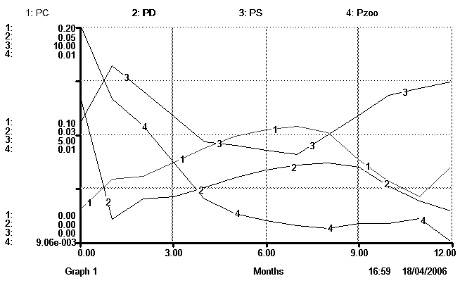
Fig. 2. Dynamic of PC, PD, PS, Pzoo in 12 months.
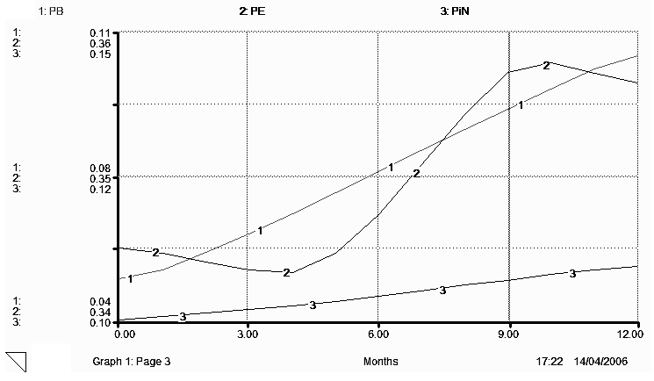
Fig. 3. Dynamic of PB, PE, PiN in 12 months.
Table 1. Decrease of Cpl, PS, and content of PS
Decreases of Cpl (%) | 50 | 75 | 90
Decreases of PS (%) | 48.89 - 49.53 | 73.46 - 74.16 | 87.96 - 89.01
Content of PS (mg/l) | 2.08 - 4.14 | 1.08 - 2.12 | 0.49 - 0.9
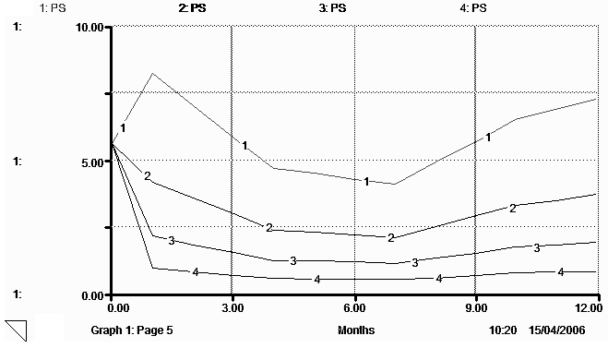
Fig. 4. Dynamic of PS content when Cpl decreases:
1 - non-decrease, 2 - decreases 50%, 3 - decreases 75%, 4 - decreases 90%.

4. Conclusions
- Results obtained from mathematical models of total phosphorus amount and phosphorus concentration in Bay Mau Lake show that the lake contains too much phosphorus. Phosphorus loading in fact is hundreds times higher than the allowable level. Compared to empirical watershed model, the Jorgensen model gives better result, which is closer to the measured data.
- Jorgensen phosphorus exchanging model reflects theoretical rules relating to the lake's ecosystem. The result of this model is close to the fact. The content of PS exceeds allowable limit. The content of other types of phosphorus increases over time. Phosphorus in the lake is increasing.
- When phosphorus concentration of sewage decreases up to 90%, the content of PS fluctuates between 0.49 and 0.9mg/l. This value is still much higher than allowable standard (0.03mg/l). Therefore, to reduce the content of PS below 0.03mg/l, we should perform waste water treatment in combination with other methods.
- Analyses above demonstrate that the results of models are reliable and can apply to other lakes.
References
- B. Hannon, M. Ruth, Modeling Dynamic Biological Systems, Springer-Verlag, New York, 1997.
- National Hydro-Meteorological Service of Vietnam, The report on climate of the monitoring station in Northern part of Vietnam, Scientific and Technical Hydro-Meteorological Journal No. 2(2005) - No. 1(2006) 56 (in Vietnamese).
- N.X. Nguyen, T.D. Ha, Quality of river and lake water and environmental protection of the water, Publishing House of Science and Technology, Hanoi, 2004 (in Vietnamese).
- H.T. Hai et al., Preliminary assessment of external nutrient Nitrogen and phosphorous discharged into Ba Be Lake, Institute of Ecology and Biological resources, 2001 (in Vietnamese).
- S. E. Jorgensen, Application of Ecological Modeling in Environment Management, part A, Elsevier Scientific Publishing Company, Amsterdam, 1983.
- Centre for Environmental Technology and Industrial Area (CETIA), Hanoi University of Construction, Report of research project "Assessment of water quality change of 5 lakes after improving and promoting treatment methods", Hanoi, (2005) 40 (in Vietnamese).

Corresponding author. Tel.: 84-4-5584921. E-mail: huongjgep@gmail.com

