A knowledge management approach of ICT
C. Rosenthal-Sabroux^{1,*}, M. Grundstein²
¹University Paris Dauphine, LAMSADE, Place du Maréchal De Lattre de Tassigny 75775 Paris Cedex 16
²Paris-Dauphine University, MG Conseil, 4, rue Anquetil , 94130 Nogent sur Marne
Received 31 October 2007

Abstract. Under the influence of globalization, and the impact of Information and Communication Technologies (ICT) that modify radically our relationship with space and time, the hierarchical company locked up on its local borders becomes an Extended Company, without borders, opened and adaptable. In this context, from a Knowledge Management view point, the employees at their computerized desktop need to access new types of information. In this paper, we introduce our group of researches’ definition of Knowledge Management. Then we present the concept of Extended Company and we analyze the new information needs of the Knowledge Worker at his computerized desktop. We propose the Knowledge Worker Desktop’s Model (KWDM), which highlights three types of data to be considered in the development of ICT applications: "mainstream" data, "shared" data, and "source-of-knowledge" data. We conclude with the perspective of a Digital Information System (DIS) centered on the knowledge-worker, which becomes a new way to design the architecture of a Digital Information System adapted to an Extended Enterprise.
Keywords: Digital Information System, Extended Company, Knowledge Management, Knowledge Worker.

1. Introduction
In 1990, the IMKA (Initiative for Managing Knowledge Assets) project defined for the first time the concept of Knowledge Assets:
« Knowledge assets are (defined as) those assets that are primary in the minds of company's employees. They include design experience, engineering skills, financial analysis skills, and competitive knowledge » [1]. Since that time, the concept of Knowledge Management emerged and was developed in numerous publications [2-6]. At the same time, under the influence of globalization, and the impact of Information and Communication Technologies (ICT) that modify radically our relationship with space and time, the hierarchical company locked up on its local borders becomes an Extended Company, without borders, opened and adaptable. In this context, from a Knowledge Management view point, the employees at their computerized desktop need to access new types of information. In this paper, we introduce our group of researches' definition of Knowledge Management. Then we present the concept of Extended Company and we analyze the new information needs of the Knowledge Worker at his computerized desktop. We propose a Knowledge Worker Desktop‘s Model (KWDM), which highlights three types of data to be considered in the development of ICT applications: "mainstream" data, "shared" data, and "source-of- knowledge" data. We conclude with the perspective of a Digital Information System centered on the knowledge-worker, which becomes a new way to design the architecture of a Digital Information System adapted to an Extended Enterprise.
2. Knowledge management
Today, the concept of KM highlights a broad range of topics and become a fuzzy concept taking as many senses as people speaking about it. With regard to this question, since 2001, our group of research has adopted the following definition of KM:
“KM is the management of the activities and the processes that enhance the utilization and the creation of knowledge within an organization, according to two strongly interlinked goals, and their underlying economic and strategic dimensions, organizational dimensions, socio- cultural dimensions, and technological dimensions: (i) a patrimony goal, and (ii) a sustainable innovation goal.”
This definition implies three postulates: (i) company’s knowledge includes two main categories of knowledge; (ii) knowledge is not an object; and (iii) knowledge is linked to the action. We define these postulates below.
2.1. Postulate one: Company’s knowledge includes two main categories of knowledge
Within a company, knowledge consists: on the one hand, in explicit knowledge composed of all tangible elements - we call it “know-how”, and on the other hand, in tacit knowledge [7], which includes intangible knowledge - we call it “skills” (Ref. Figure 1). The tangible elements are formalized in a physical form (databases, procedures, plans, models, algorithms, analysis and synthesis documents) and/or are embedded in automated management systems, conception and production systems, and in products. The intangible elements are inherent to the individuals who bear them, either as collective knowledge (the “routines” – non-written individual or collective action procedures [8], or as personal knowledge (skills, crafts, “job secrets”, historical and contextual knowledge, environmental knowledge – clients, competitors, technologies, socio-economic factors).
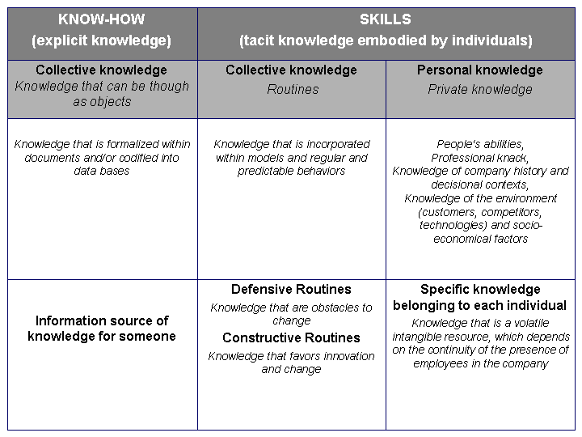
Fig. 1. The two main categories of company’s knowledge.
2.2. Postulate two: Knowledge is not an object
Knowledge lies in the interaction between an interpretative framework incorporated within the head of an individual or embedded into an artefact, and data.
This postulate is based on the theories developed by S. Tsuchiya [9], who deals with the construction of tacit individual knowledge. According to his research, the tacit knowledge, which lies within one’s brain, is the result of the meaning one allocates-through one’s interpretative schemes - to the data that one perceives as part of all the information received. This individual knowledge is tacit and it may or may not be expressed. It becomes collective knowledge as soon as it is shared by other individuals, whose interpretative schemes are “commensurable”, i.e. schemes that enable a minimal common level of interpretation, which is shared by all members of the organization.
2.3. Postulate three: Knowledge is linked to the action
From a business perspective, knowledge is created through action. Knowledge is essential for the functioning of business and projects processes, and is finalized through their activities. Hence, one has to be interested in the activities of the actors – decision-makers – engaged in the processes contained in the company’s missions. This point is included in the use of the concept of knowledge, which cannot be separated from the individual placed within the company, his/her actions, decisions and relations with the surrounding systems (people and artefacts).
We developed a Model for Global Knowledge Management within the Enterprise (MGKME) based on these postulates [10]. This model considers relevant infrastructure for KM that is adapted sets of devices and means for action. In particular, the infrastructure derives from the Nonaka and Takeuchi’s SECI model [6], and the Japanese concept of Ba suggested by Konno and Takeuchi [11], which “can be thought as a shared space for emerging relationships” (p. 40). Ba can inspire infrastructures that bring the dynamism to create continually new knowledge through a cycle of converting tacit knowledge into explicit knowledge and then reconverting it into tacit knowledge.
3. The extended company
Under the influence of globalization, and the impact of Information and Communication Technologies (ICT) that modify radically our relationship with space and time, the company increasingly develops its activities in a planetary space with three dimensions:
- a global space covering the set of the organization that are the geographic places of implantation,
- a local space corresponding to the subset of the organization situated in a given geographic zone, and
- a space of influence that covers the field of interaction of the company with the other organizations.
The hierarchical company locked up on its local borders becomes an Extended Company, without borders, opened and adaptable. Furthermore, this Extended Company is placed under the ascendancy of the unforeseeable environment that leads towards uncertainty and doubt (see figure 2).
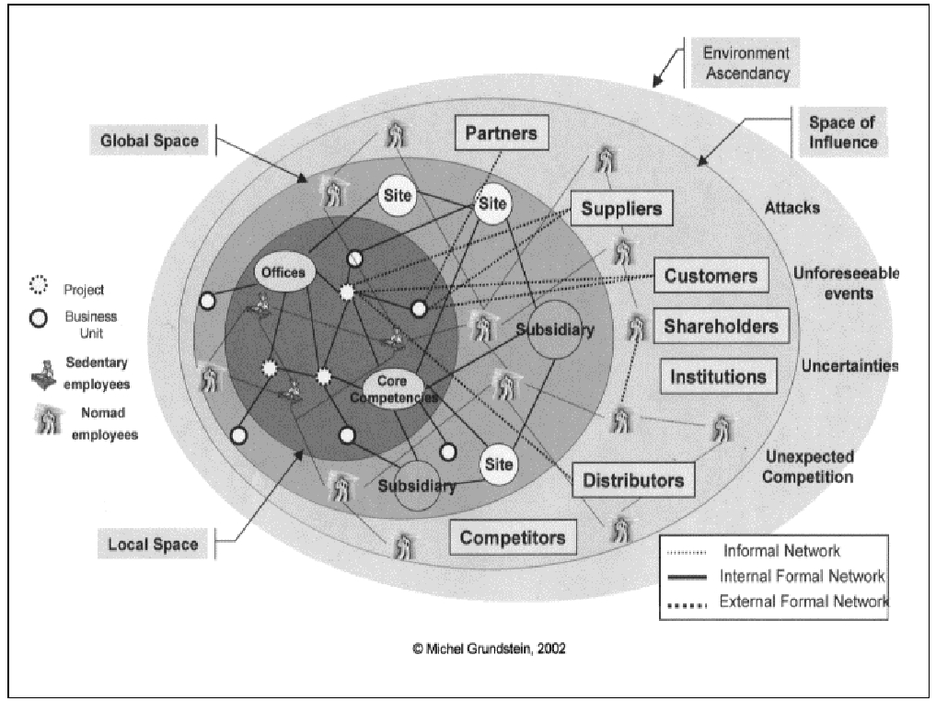

Fig. 2. The information networks within the extended company.
The Extended Company meets fundamental problems of information exchange and knowledge sharing among, on the one hand, its formal entities distributed in the world (offices, core competencies, business units, projects) and on the other hand, the company's employees (nomadic or sedentary), bearers of diversified values and cultures according to the places of implantation.
Two networks of information overlap:
- A formal information network between the internal or external entities, in which circulate data and explicit knowledge; this network is implemented under intranet and extranet technologies.
- An informal information network between nomadic or sedentary employees; this network favors information exchange and tacit knowledge sharing. It is implemented through Information and Communication Technologies as Web 2.0 [12].
The problems occur when nomadic employees placed in new, unknown or unexpected situations, needs to get “active informations” that are information and knowledge they need immediately to understand the situation, solve a problem, take a decision, and act.
4. The knowledge worker at his computerized desktop
After having introduced the notion of “Knowledge Worker”, we point out the new employee’s information needs from the KM viewpoint. Then we consider a digital information system centered on the knowledge-worker, and we highlight the necessity to consider three types of data in the development of ICT applications. Finally we propose a Knowledge Worker Desktop‘s Model (KWDM).
4.1. The Knowledge Worker
“What makes knowledge valuable to organizations is ultimately to make better the decisions and actions taken on the basis of knowledge.” [13] Nowadays, Information and Communication Technologies (ICT) modify radically our relationship to space and time. In this context, initiatives and responsibilities are increasing. Employees are placed in situations in which they need to take decisions. They are becoming Decision-Makers, whatever their roles and their hierarchical positions. For their missions, through their computerized workstation, they must have access to information and knowledge widely distributed in their organization. Furthermore, to make decision and act they activate their cognitive processes and produce new knowledge. According to the term coined by Peter Drucker around 1960 [4] they become ‘knowledge workers’, who are “knowledge executives who know how to allocate knowledge to productive use - just as the capitalists knew how to allocate capital to productive use; knowledge professionals; knowledge employees” (p. 7).
In short, a ‘knowledge worker’ is a worker who develops and uses knowledge. Porter, Bennet, Turner and Wennergren [14] extended this definition as “worker whose job depends on the processing and use of information in a continuously changing work environment (p. 331).”
Afterwards, we define a Knowledge Worker as follows: “A Knowledge Worker is a worker whose job depends on the processing and use of knowledge and information in work situations that require decision making, and demand his initiative and responsibilities.” This definition points out the increasing autonomy of people due to Information and Communication Technologies.
4.2. The new employees’ information needs from KM viewpoint
In companies, initiatives and responsibilities are increasing, whatever the individuals’ hierarchical levels and roles are. Employees are placed in situations in which they need to take decisions. They become decision-makers who use and produce more and more knowledge as a basis for their efficiency.
Their knowledge is the crucial factor enabling them to enhance their competencies, and thus improve their decision- making processes. To answer their missions, these individuals, commonly pointed out as « Knowledge-Workers», have to access knowledge and expertise widely distributed in their organization. They must rely on the formal and the informal information networks of the company through their sedentary or mobile computerized workstation. The computerized workstation becomes a window opened on the company’s planetary space of activities. Thus, the essential role of the digital information system is to provide relevant information to each employee at all levels of the hierarchy, so that he can control, make decisions and undertake actions.
4.3. The digital information system, centered on the knowledge-worker
Beyond the technical infrastructures that are implemented, the digital information system has to bring, to each individual, useful information. Moreover the digital information system has to supply means to share the knowledge with distant colleagues, and to enable access to essential knowledge in order to solve problems out of routine. Knowledge Management offers a way to answer these problems, may the employee be nomadic or sedentary, and whatever his geographic location and his mode of connection to the network (computerized workstation, laptop, personal assistants) are.
The digital information system, centered on the knowledge- worker, requires a human centric design approach to place the knowledge-worker into the heart of the design process [15,16]. The design must not dissociate the knowledge- worker, stakeholder of different functional and organizational groups and lines of business or projects, from the professional processes in which he is engaged, the actions he performs, the decisions he makes, the relations he has with his company environment (persons and artifacts).
Thus, our researches, focused on knowledge management and the knowledge-worker at his computerized desktop, have led to distinguish three types of data to be processed by the digital information systems: the mainstream data, the source- of knowledge data, and the shared data [17].
1) The “Mainstream” Data
The “Mainstream” data make up the flow of information that informs us on the state of a company’s business process or working information needed by each individual to act. For example, in a bank, the Digital Information System is a company’s production system. In this case, the “Mainstream” data inform on the state of the information related material to be transformed, and on the state of the Digital Information System that carries out this transformation. On the contrary, in the industry, the company’s production system involves physical materials. In this case, the “Mainstream” data provide information on the state of that material before and after the transformation, and give information overall environment that makes this transformation possible.
2) The “Source-of-Knowledge” Data
The “Source-of-Knowledge” data are the result of a knowledge engineering approach that offers techniques and tools for identifying, acquiring and representing knowledge. This knowledge, encapsulated in computer programs capable of reconstructing it as information immediately understandable to human beings, thus becomes accessible and can be handled. This leads us to integrate into the digital information system specific modules called “Source-of- Knowledge” data systems, which both in their conception and in the techniques used to implement them influence the results produced through new orientations in knowledge engineering research [18].
3) The “Shared” Data
Moreover, the information and communication technologies have caused a rupture with older technologies, a rupture linked to the relationship of human beings to space, time and capacity to be ubiquitous, which take us from the real world to a virtual one, from the manipulation of concrete objects to abstract ones. The instantaneous transfer of digitalized multimedia documents which include texts, images and sounds, the possibility of asynchrony of information exchanges which transforms our relationship with time and space, electronic conferences which allow us to be in different places at the same time, engender a transformation in our behavior at work. They accelerate the publication and dissemination of documents, they facilitate working in groups, they modify our means of communication and, above all, they speed up the transmission and sharing of tacit knowledge which, up to now, operated from person to person on a master apprentice basis. In short, they generate processes of information exchange that were unbelievable with previous technologies. Information processed by these technologies is called “shared-data”.
4.4. The Knowledge Worker Desktop‘s Model (KWDM)
Within the Company, knowledge workers find themselves confronted with situations that go beyond daily routine, situations in which they must evaluate all possible choices in terms of criteria relevant to a given set of goals. Taking into consideration all available information (“Mainstream” data, “Shared” data, “Source-of-Knowledge” data), their own intentions, any restrictions which influence their decisions and their knowledge and know-how, they must analyze and process information in order to make these choices. We have materialized this vision under an empirical model form so called KWDM described below (see figure 3).
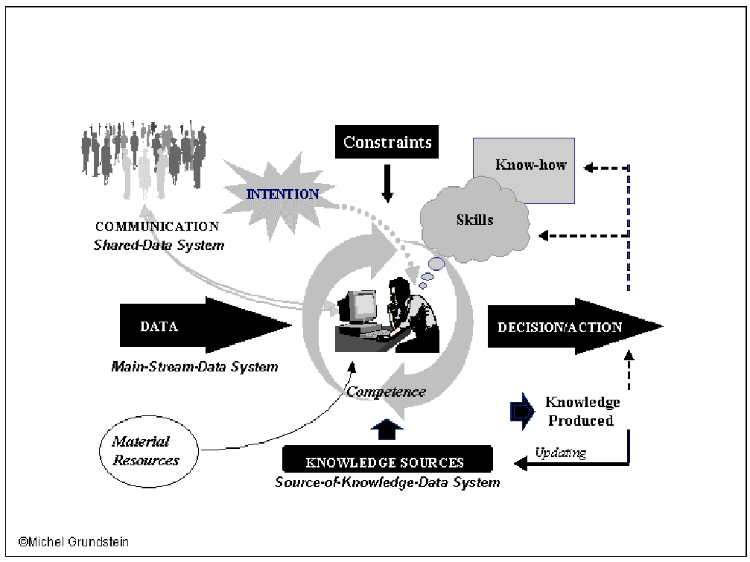

Fig. 3: The Knowledge Worker Desktop’s Model (KWDM).
The Knowledge Worker engaged in business or project line processes is subjected to constraints inherent to these processes (available financial and human resources, costs, delays, quality, security, specific objectives to achieve). He uses physical resources (working environment, tools). He possesses knowledge and skills. Through the “Mainstream data System”, he receives and gets "current data" that are data relative to the tasks he has to execute (data on the status of the work he is achieving, data on evolving events to take in charge, management and technical data). Through the “Shared data System”, he communicates in real time with the other actors; he exchanges information and shares tacit knowledge. To make a decision and act, he activates a cognitive process that shows his capability to put together his knowledge, his skills and his ethical attitude, under constraining conditions of his task situation. Here, we refer to his competence.
His knowledge and skills can prove to be insufficient to solve the out-of-routine problem he is confronted with. In that case, and according to his intention, which depends on his freedom of action, he needs to get additional data stored in the “Source-of-Knowledge data System”. These data, by interaction with his cognitive system, become new knowledge enabling him to solve the problem, make decision and act. During this process, there is a production of new knowledge. This new knowledge, on the condition of being acquired and formalized, can update and complete the “Source-of- Knowledge” data System [15]. What is essential in this vision of things is the creative relation, between the knowledge worker and his activity, taking into account his “intention”, the end purpose of his action, and the orientation of knowledge towards an operational objective [19].
The KWDM is a model that one uses as a pattern of reference to conceive digital information system architecture using multifunctional software applications characterized by the type of data they are processing.
For example, we used it to enhance a Group Decision and Negotiation System (GDNS) for Operational Performance Management (OPM) implemented in an Entertainment Company based in France. This GDNS addresses a Zero Latency Organization problem that is to provide decision makers, both strategic and operational, with the insight they need to interpret multiple and complex operational data, and take immediate decision close to the action.
The results highlighted the importance of the “Intention” (associated to the enterprise culture and the personal skill of the Operational Control Center analysts with the objective of optimizing the operational performance), and the importance of “Shared” data system. This analysis led to highlight the formalization of the different data flows, the impact of the system on the organization, and to confirm the importance of human factor in the group decision and negotiation process. Furthermore, it opened new perspectives about the role of the system in the organizational learning process to insure the Business Continuity Plan. Today, the Company uses the KWDM model as a reference for the Operational control’s change management (for impact analysis and optimization opportunities).
5. Conclusion
The analysis of extended companies from KM viewpoint highlights new employees’ information needs. More particularly, the digital information system as an essential instrument to provide Knowledge-Workers with information and knowledge those are required to accelerate and improve the reliability and the quality of their decisions. That leads to consider the vision of the knowledge-worker at his computerized desktop and leads us to propose the KWDM model, which distinguishes three types of data to be processed by the digital information systems: the mainstream data, the source-of-knowledge data, and the shared data. Therefore, the digital information system centered on the knowledge-worker becomes a new way to design the architecture of a Digital Information System adapted to an Extended Enterprise. From this view point, for information system engineering, it is very important to take into account:
- Production and deployment of software, like the Unified Modeling Language (UML) and The Unified Software Development Process [20],
- ERP contribution,
- Technologies for distributed and shared treatment (Groupware, workflow, CSCW…),
- Technologies for knowledge management to activate the capitalization on knowledge cycle to identify, preserve, increase, actualize the source-of-knowledge data,
The stake becomes to find the best methods, techniques and tools in order to design a Digital Information System (DIS) with all these characteristics. A DIS designed with these different aspects provides companies with the fundamental support corresponding to a voluntarily and aware Knowledge Management approach. This is the sense that we give to our research group.
References
- IMKA Technology Technical Summary, (IMKA project was formed by Carnegie Group, Inc., Digital Equipment Corporation, Ford Motor Company, Texas Instruments Inc., and US West Advanced Technologies Inc), 30 July 1990.
- T.A. Stewart, Brain Power, “How Intellectual Capital Is Becoming America's Most Valuable Asset”. Fortune, 3 June 1991.
- K. M. Wiig, “Knowledge Work in the Corporation, IAKE'92 Tutorial”. Third Annual Symposium of the International Association of Knowledge Engineers, Washington DC, November 16-19, 1992.
- P. Drucker, “Post-Capitalist Society”. Oxford: Butterworth-Heinemann Ltd, 1993.
- D. Léonard-Barton, “Wellsprings of Knowledge - Building and Sustaining the Sources of Innovation”. Harvard Business School Press, Boston, Masachusetts, 1995.
- H. Nonaka, H. Takeuchi, “The Knowledge Creating Company - How Japanese Companies Create the Dynamics of Innovation”, Oxford University Press, 1995.
- M. Polanyi, “The tacit dimension”. London: Routledge & Kegan Paul Ltd, 1996.
- Nelson, Winter, “An Evolutionary Theory of Economic Change”. Cambridge, MA: Harvard University Press, 1982.
- S. Tsuchiya, “Improving Knowledge Creation Ability through Organizational Learning”, In ISMICK'93 Proceedings, International Symposium on the Management of Industrial and Corporate Knowledge Compiègne, France: University of Compiègne (1993) 87.
- M. Grundstein, “Knowledge Workers as an Integral Component in Global Information System Design”. In W. Law (Ed.) Information Resources Management: Global Challenges (chap. XI, pp. 236). Hershey, PA: Idea Group Inc, 2007.
- I. Nonaka, N. Kono, Ikujiro Nonaka, Noboru Konno, “The Concept of “Ba”: Building a Foundation for Knowledge Creation”. In California Management Review, Vol 40, N°3, Spring 1998 Special Issue on Knowledge and the Firm, edited by Robert E. Cole, HAAS School of Business, Berkeley, CA, (1998).
- T. O’Reilly, “What is Web 2.0? Design Patterns and Business Models for the Next Generation of Software”, 2005: http://www.oreillynet.com/pub/a/oreilly/tim/news/2005/09/30/what-is- web-20.html Extrait octobre 2007
- T.H. Davenport, L. Prusak, “Working Knowledge. How Organizations Manage What They Know”. Harvard Business School Press, Boston, 1998.
- D. Porter, A. Bennet, R. Turner, D. Wennergren, “The Power of Team: The Making of a CIO”. Washington, DC: Department of the Navy Chief Information Officer (DON CIO), www.doncio.navy.mil, 2002.
- C. Rosenthal-Sabroux, “Contribution méthodologique à la conception de systèmes d‘information coopératifs: prise en compte de la coopération homme/machine”, Mémoire HDR, Université Paris-Dauphine, Paris, 1996.
- N. Kettani, D. Mignet, P. Paré, C. Rosenthal-Sabroux, De Merise à UML. Editions Eyrolles, Paris, 1998.
- M. Grundstein, C. Rosenthal-Sabroux, “Vers un système d’information source de connaissance” . In C. Cauvet and C. Rosenthal-Sabroux (Eds), Ingénierie des Systèmes d’Information (chapitre 11, pp. 317), Hermès sciences Publications, Paris, 2001.
- J. Charlet, M. Zacklad, G. Kassel, D. Bourigault, “Ingénierie des connaissances, Evolutions récentes et nouveaux défis”, Editions Eyrolles France Télécom-CENT, Paris 2000.
- M. Grundstein, “From capitalizing on Company Knowledge to Knowledge Management”, in D. Morey, M. Maybury and B. Thuraisingham (Eds), Knowledge Management, Classic and Contemporary Works, The MIT Press, Cambridge, Massachusetts, 2000 (chapter 12, pp. 261).
- Ph. Kruchten, The Rational Unified Process, Addison-Wesley Longman, Inc, Reading, Massachussets, 1998.

Corresponding author. Email: sabroux@lamsade.dauphine.fr

