USING JAVASCRIPT FOR SOME INTERACTIVE OPERATIONS IN VIRTUAL GEOGRAPHIC MODEL WITH GEOVRML

Nguyen Đinh Hoa

Information Technology Institute, Vietnam National University – Hanoi, Vietnam

Email: hoand@vnu.edu.vn

ABSTRACT
Recently, the Geographic Information System (GIS) based on 3-dimensional geoprocessing technology and Internet environment are regarded as one of emerging issues in the GIS fields. This presentation reports on virtual geographic modeling using GeoVRML and adding some interaction functions for geometric and metric analysis. Using java script nodes in standard VRML we introduce interactive operations such as vertical exaggeration, moving secant plane, measuring the distance between two points, showing 3D buffer, etc.. .

1. INTRODUCTION
1.1 3D modeling in GIS
We are living in the world of three-dimensional. The traditional GIS uses the two dimensional maps to model the real world. but it’s hard to imagine the 3D objects through 2D projections. On the 2D map, some aspects of the spatial relation between objects may lost and it causes difficulties to understand, to analyze and to evaluate the real world scenes. The need to visualize and explore digital spatial data in 3D has became widely recognized.
Several leading GIS software companies have developed extensions to their products to support 3D GIS ([4,5]).
The most important products are mentioned below
- 3D Analyst in ArcGIS (ESRI Inc, www.esri.com);
- Imagine VirtualGIS (ERDAS Inc., www.erdas.com);
- GeoMedia Terrain (Intergraph Inc., www.integraph.com);
- Geomatica (PCIGeomatics, www.pcigeomatics.com).
All these products provide excellent tools for 3D visualization, animation and navigation through 3D models. Most of them offer tools to manipulate spatial data such as surface generation, volume calculation, draping, terrain inter-visibility, etc. However, The full 3D GIS functionality in terms of 3D structuring, 3D manipulation and 3D analysis are still to desire. The z-coordinate is basically an attribute and 3D topological relationship analysis need more researches in the future.
According to the OpenGIS specifications, the geometric model provides direct access to the coordinates of individual spatial object called geographic feature and the topological model refers to the composing smaller elements (primitives) into more complex object and encapsulates the spatial relationships of composing element. The OGC proposes the specifications of simple geometric features and complex features.
1.2 Spatial analysis in 3D GIS
Universal GIS operations are
- Basic operations of retrieval, selective search, reclassification (overlays, combine)
- Geometric analysis: buffering, intersection, merge
- Quantitative analysis: measurement of distances, lengths, perimeters, areas, volumes
- Topographic analysis: 3D analysis based on DEM data, including define slope/aspect, catchments/basin; drainage/network; view shed, etc.
In 3D GIS, the operations are performed on 3-dimensional objects. By example, geometric analysis operations are 3-dimensional buffering, intersection, merge, etc. Thank to 3D visualization of data the terrain analysis operations become more clear and straightforward.

2 GEOVRML - INTEGRATION OF GIS AND VIRTUAL REALITY
2.1 VRML
Virtual Reality Modeling Language (VRML) is an ISO standard for describing interactive 3D objects and the real worlds. The tools for display VRML files (.wrl file extension) called VRML browsers. There are several VRML plug-ins to web browsers which makes Web-based 3D visualization feasible. The most famous are
- Cortona (www.parallelgraphics.com). Cortona VRML Client can be installed to work with the latest versions of Internet Explorer, Netscape, Mozilla Firefox and Opera.
- Cosmo Player work with web browsers such as Netscape, Firefox, Mozilla and Opera. Cosmo Player might now not work in Internet Explorer because of Windows security reason.
2.2 GeoVRML
GeoVRML (www.geovrml.org) is an extension of VRML with geo-nodes. GeoVRML has been proposed and implemented to provide geoscientists with the ability to model dynamic 3-D geographic data that can be distributed over the web and interactively visualized using a standard browser configuration. The GeoElevationGrid node provides the capability to define a grid of height values offset from the surface of ellipsoid modeling the Earth. All data are specified in latitude/longitude coordinates in the VRML file and then transparently converted to an ellipsoidal model. In addition, GeoVRML is an open standard. Its specification is published openly and a source-level sample implementation is provided.
To enable the VRML viewer to display GeoVRML we need to install one Java plug-in. The GeoVRML runtime plug-in can be found at the GeoVRML website (www.geovrml.org/1.0/download/). Especially, the Cortona 3 VRML browser provides native support for GeoVRML 1.0. That is, all of the GeoVRML nodes have been ported to C++ and implemented within the browser, rather than as Java Script nodes. This will increase the speed because no GeoVRML run-time installation requirements.

2.3 Tools supporting GeoVRML
Several GIS software companies have developed tools that support the GeoVRML file format. These include modeling tools that can export to GeoVRML, conversion tools to take standard mapping products and produce GeoVRML representations of these, and visualization technologies that allow the user to browse GeoVRML content.
ArcView/ArcInfo: The 3D Analyst extension for the ArcView/ArcInfo version 8.1 released in April of 2001, has been added GeoVRML support. Now it allows export of GIS data to the GeoVRML file format for viewing over the Web.
TerraVision (www.ai.sri.com/) is an Open Source distributed, interactive terrain visualization system developed by SRI International. TerraVision permits to overlay 3-D VRML and GeoVRML models. TerraVision uses the TsmApi library.
tsmApi (www.tsmApi.com/) : The tsmApi library (Tile Set Manager API) includes a VRML97 parser and provides functions for generating tiled multiresolution terrains from various raw imageries, and then converting these into a GeoVRML 1.0 representation, using GeoLOD and GeoElevationGrid nodes. The library is Open Source and includes a suite of tools built on the library, such as the text2geovrml converter.
DEM2GeoEG (www.ai.sri.com/software/DEM2GeoEG) is a program to convert USGS Digital Elevation Model (DEM) data into a VRML file that uses the GeoVRML 1.0 GeoElevationGrid.
ShapeViz (www.my3d.com/ShapeViz.htm) is an application that can take ArcView Shape files, view them, and convert them into VRML and GeoVRML. Bashir Research have just released version 1.2 of ShapeViz utility.
X3D-Edit: X3D-Edit is an Extensible 3D (X3D) graphics file editor that uses the X3D Document Type Definition (DTD) in combination with Sun's Java, IBM's Xeena XML editor, and an editor profile configuration file. X3D-Edit enables simple error-free editing, authoring and validation of X3D or VRML scene-graph files
3 SOME INTERACTION FUNCTIONS FOR GEOMETRIC AND METRIC ANALYSIS
Use available supports to handle user interactions in VRML, we try to write some simple Java script functions to deal with 3D objects in model or to carry out metric operations. Our purpose is introducing the possibilities of integration of geographical model with virtual reality.
3.1 Vertical exaggeration
The GeoElevationGrid node gives us the capability to build 3D model of terrain surface easily. Moreover, this node has the field yScale acting as a multiplier to elevation values. The default value 1.0 means that the original elevation values are used. By giving the field yScale a value bigger than one, we can accentuate areas of high elevation or the variation of slopes, .. The event set_yScale permit to change the vertical exaggeration ratio dynamically.

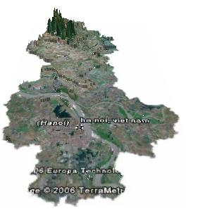

Figure 1: The terrain surface of Hanoi region with vertical exaggeration of 20
3.2 Secant plane
A very thin box can be viewed as a plane sheet. We can show one secant plane sheet cut through 3D model of one region and using the mouse to move the sheet in a translational movement. This function can be used to visualize, by example, the water level to indicate the submerged area in case of flood.

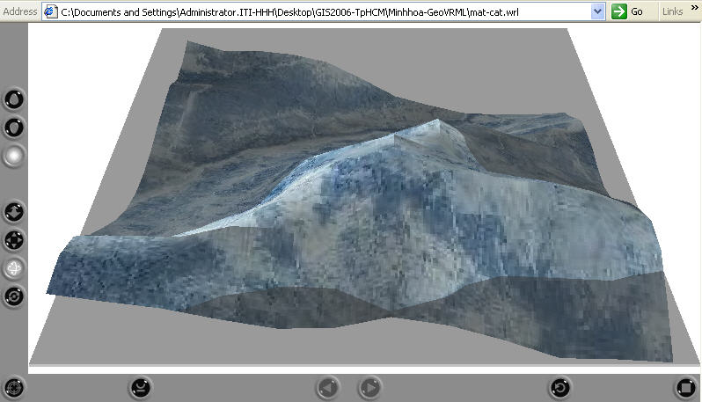

Figure 2: Show a secant plane through 3D model of region
3.3 Three dimensional buffering
We can show the 2-dimentional buffer of one point as a circle and the 3-dimentional buffer as a sphere. Using the mouse we can move it anywhere. The 3D buffering along one arc or one polyline can realize with the help of the Extrusion node.

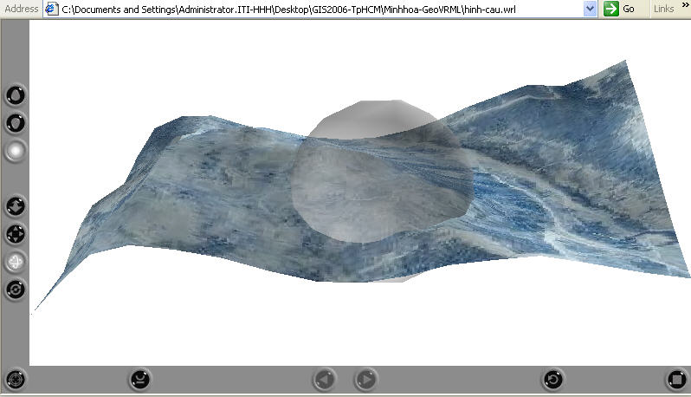
Figure 3: 3D buffering of one point

3.4 Retrieve geographic coordinates
One simple Java Script function permit to retrieve the geographic coordinates and elevation of one site in model pointed by mouse and show on the screen.

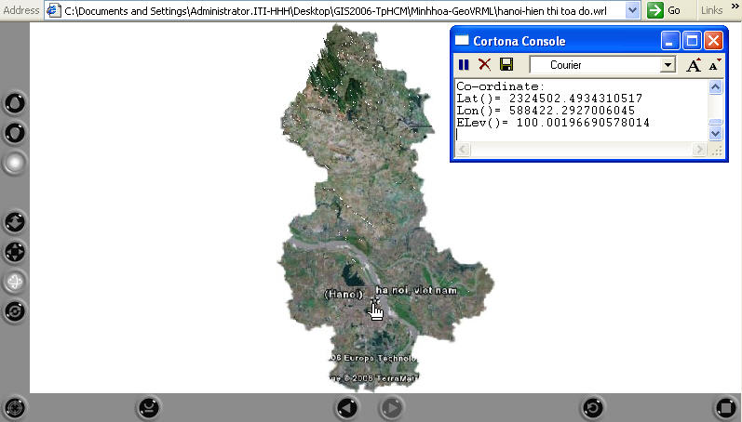

Figure 4: Show geographic coordinates

3.5 Distance measuring
Having geographic coordinates of two points, we can calculate the distance in 3D space between them

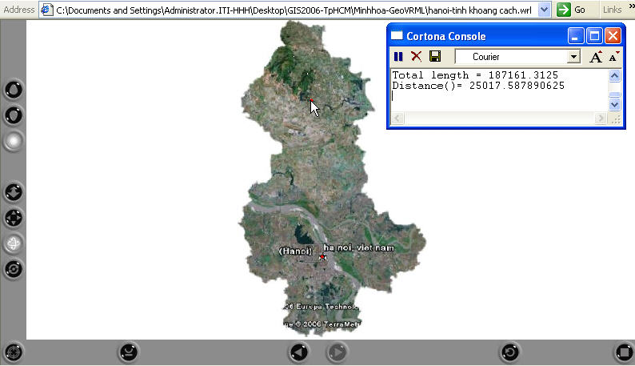

Figure 5: Show the distance between two sites

4 CONCLUSIONS
GeoVRML provide geoscientists with an excellent medium of representing and visualizing geographic data in a dynamic, interactive, and web-accessible format. The integration of GIS and virtual reality gives possibilities to build 3D geographic model easily and to use available interactive capabilities provided by VRML in analyzing the data. We have tried to present potential benefits of this approach through implementing some simple utility functions with hope that it help to develop Web GIS applications of more suggestiveness and attractiveness.

REFERENCES
[1] Billen R., S. Zlatanova, P. Mathonet and F. Boniver, 2002. “The Dimensional Model: a framework to distinguish spatial relationships” Advances in Spatial Data handling, D.Richardson, P.van Oosterom (Eds.), Springer, Ottawa, Canada, 9-12 July, 2002, pp. 285-298.
[2] Çöltekin, A., Haggrén, H., 2000. “Vrml as a tool for web-based, 3d, photo-realistic gis”, IAPRS, Vol. XXXIII, Amsterdam.
[3] Huang, B., Jiang, B., Li, H., 2001, “An integration of GIS, virtual reality and the Internet for visualization, analysis and exploration of spatial data”, Int. j. geographical information science, 2001, vol. 15, no. 5, 439 - 456
[4] Hilbring D., 2002, “Interactive analysis for 3D-GIS tools”, Symposium on Geospatial theory, Processing and Applications, Ottawa 2002.
[5] Kim K.-Ho , Lee K., Lee H.-G.,Ha Y. –L., 1998. “Virtual 3D GIS's Functionalities Using Java/VRML Environment”, Proceedings of the Earth Observation & Geo-Spatial Web and Internet Workshop '98.
[6] Reddy M., Iverson L., Leclerc Y. G., Heller A., “GeoVRML: Open Web-based 3D Cartography”.
[7] Reddy M., Iverson L., Leclerc Y. G., “Under the Hood of GeoVRML 1.0”, SRI International
[8] Zlatanova, S., Rahman, A.A. and Pilouk, M., 2002. “Trends in 3D GIS development” Journal of Geospatial Engineering, Vol. 4, No. 2 (December, 2002), pp.1-10.
[9] Zlatanova, S., Rahman, A.A. and Pilouk, M., 2002. “3D GIS: current status and perspectives” Proceedings of the Joint Conference on Geo-spatial theory, Processing and Applications, 8-12 July, 2002, Ottawa, Canada.

